**My Consumer Citizenship Journal**

# **Introduction**

I am Anne, an international student at Capilano University. Currently, I am studying Tourism Management, and in one of my classes we were asked to make a journal about a five-day period, where we focus on environmental and citizenship acts, write down things that might be good and helpful and things that might not. I chose to take the last week of January. My exact period is: Tuesday, the 29th of January – Saturday, the 2nd of February 2019.

My goals and values for this project are the following:

* Try to cook more at home and take your own food to school
* Be more aware about your environment and tell your friends about what you are doing
* Try to create less waste, especially plastic
* Look around school, check where you can learn more and help others

# **The Period**

***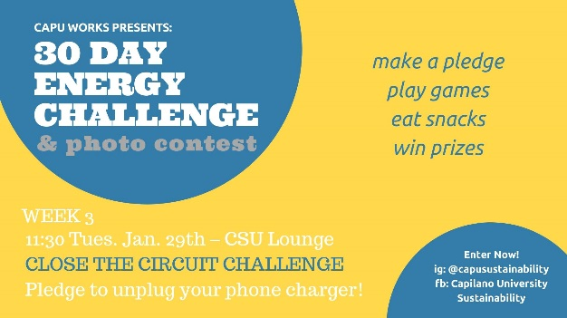*Tuesday, the 29th of January**

On Tuesday I went to University by bus. I only had one course and after I wanted to go join CapU Works on one of their events in the library lounge. I heard about them before and already competed in one of their challenges. One of my friends joined me, so we went there together and joined the group for a quiz about energy savings. It was actually very interesting,and I learned a few new things. My friend and me both took a pledge, this week it was about unplugging a device completely form the socket.

Later on, I went to my job, where I am teaching a little class of seven-year-olds German. They are very eager to learn and by coincident we had to talk to them about garbage. At this point I told them, how important recycling is, and I feel like they understood it very well.

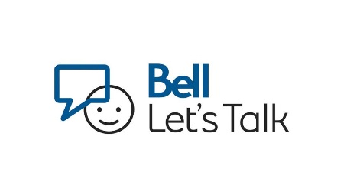**Wednesday, the 30th of January**

On Wednesday I went to class as usual. In the morning I went to my Environmental Stewardship class, which I really like. It teaches me a lot of stuff, that I was not aware of today and changes me in a way I didn’t expect. Later, in my break, I went to see a friend in the cafeteria where they had a few stands form Bell Talk. We were both wondering what was happening, so we went there, and they informed us about the mental health awareness day. We both wrote down a few words for a good cause. I believe, that things like that are good to be done in schools and universities. Those are the places were a lot of people have problems or still need to be educated about something, but also a lot of people who can share their experiences and who can help.

This day I pledged to cook more by myself and also take something to school, instead of buying something in the cafeteria. I feel like that worked really well, if you find the time and motivation to cook all of this. I even cooked something for my boyfriend, who usually gets a lot of food to-go or eats in restaurants. So now two people could benefit from this action. The food that I bought was well selected, regarding plastic and other waste. But I did not consider the meat, to be honest, it is still very hard for me to renounce meat in my diet.

**Thursday, the 31st of January**

On Thursday I had no school and no special plans. I did cook again for my boyfriend and me, so we wouldn’t go out to buy something and also eat healthy. Since I was also spending a lot of time at home, I focused more on energy use in the household. I turned the TV off completely and plugged the microwave out. From the Tuesday challenge I heard, that the microwave actually takes more energy while showing the clock, then the few minutes that it cooks your food.

**Friday, the 1st of February**

Friday, I went school by bus. On this note, I would like to mention that I actually drove my own car a lot back in Germany, but since I am here, I only drive by bus, which I hope helps the environment more then me polluting it by my own in my car. On this day, I had a little talk about saving energy and trying to produce less waste with a few people form school. It is interesting, to see how other people do it and what their values are. Later that day, I went out and had a few drinks. I guess, that that industry might not be the most energy sufficient one. So, a few points deducted there.

**Saturday, the 2nd of February**

On Saturday, my last day of the assignment, I had to work at my other job: The JJBean Coffee Roasters; a coffee shop at English bay. This company is very aware of their part in the environment and try to be as sustainable possible, they give discounts for mugs and their own bottles, they charge a little more, if they want a paper cup, most of their ‘plastic’ things are biodegradable, they use metal spoons to stir and always try to promote buying mugs and more. We always ask them, if they need a second bag or something like that, I think that that is really awesome. There, I am always aware of how much waste we and the costumers produce and I am happy to make a change in it.

# **Conclusion**

So, what did I take from this project? I feel like I did learn quite a few new things. Also, I got upset about some things that people do, that harm the environment and that they could change so easily. The problem is mostly, that people are not aware of what they are doing. That’s why I am happy that I am taking this class right now. On another note, I felt like I also helped a few people around me. I taught my students about garbage disposal, I took two different friends to awareness and sustainable projects in my University. At my barista job, I stand behind their sustainable values and at home I can include my boyfriend in my lifestyle. I feel like those are many good roles in the society, which I can actively use to contribute towards shaping an ecologically sound future. This assignment did challenge me a lot and I took a lot away from it. I also explored my barriers, where I still have to work on myself or cannot make a rapid change yet. For example, my food consumption is definitely not that good, with all the meat that I consume almost daily. I also do love to drive, but at least I don’t get the chance to drive on my own.

In other ways I also realized the different ways around Canadian and German values with the environment. Canadians for example lay a lot of value on correct garbage disposal and on a big transport system that can take you all around without ever needing a car. While Germany might lay more value on creating things like electronic cars and so on.

In conclusion, I want to say, that I really enjoyed this project and that I want to continuously better myself in shaping a better and ecologically sound future.