|  |  |
| --- | --- |
|  | Ballard  Power Systems Financial Analysis  BFIN 241 – 01  Allen Zhu  Keyline divider beneath title  Group D:  Sam Barnett  Bruno Velez  Noah Mesfin  Philip Meng  Scott Petkau  Tony Hoang |
|  |  |

Table of Contents

**Executive Summary** **3**

**About Ballard Power Systems** **4**

**SWOT Analysis** **4**

Strengths: 4

Weaknesses: 4

Opportunities: 5

Threats: 5

**Current Events** **5**

Why Ballard’s Stock Just Dropped 7% 5

Historic Strategic Collaboration - Weichai Power and China Strategy 6

**Financial Statements** **7**

Income Statement Analysis (Horizontal and Vertical) 7

Balance Sheet Analysis (Horizontal and Vertical) 8

Balance Sheet Ratios 8

Comparatives 9

Cash and Shareholder’s Equity 9

Operating Leverage 10

**Stock Analysis** **11**

Price for the last 5 years 11

Stock price for last year 11

Benchmarking 13

**Overall Evaluation of Company Performance & Conclusion** **13**

**Recommendations** **14**

**Appendix** **15**

Income Statement 15

Balance Sheet 16

Cash Flow Statement 17

Ratios 18

**References** **19**

# 

# Executive Summary

Ballard power systems Inc. manufacturers and develops fuel cell products. Ballard power system Inc. was founded in 1979 and is operating presently. Their stock price is currently at $8.01 CAD on October 24th, 2019. This is a 79% increase from last year’s share price of $4.89 CAD. In addition, Ballard power system’s 2018 net income is a deficit of (27,323); a positive net income hasn’t been recorded in the past five years.

Although the firm’s share price has increased through the year, it does not correlate to the firm’s revenue. Ballard power systems went from 85.3 million in 2016, to 121.3 million in 2017. In 2018, the firm’s revenue was 96.6 million, an overall decrease. Since the share price increased as the revenue declined, shareholders’ confidence in the firm’s future is high.

Our report provides five years of performance and ratio analysis for Ballard power systems Inc. The primary nature and activities of the company is stated in their mission statement. *“We use our fuel cell expertise to deliver valuable and innovative solutions to our customers globally, create rewarding opportunities for our team, providing extraordinary value to our shareholders and power the hydrogen society.”* (Ballard.com,2019)

# 

# About Ballard Power Systems

Ballard Power Systems was a private company founded in 1979 and was initially named Ballard Research Inc, which main purpose was to gather research and advancing energy. In 1993, fourteen years after Ballard Power Systems were founded, Ballard Power Systems went public.

Ballard Power Systems’ vision is to become the leading global supplier of innovative clean energy and solutions to superior performance at a reduced operating cost. Ballard is a leader in fuel cell technology and is the first company to power buses for ten million cumulative kilometres of revenue service. Furthermore, Ballard Power Systems’ mission statement states, “we use our fuel cell expertise to deliver valuable and innovative solutions to our customers globally, create rewarding opportunities for our team, providing extraordinary value to our shareholders and power the hydrogen society.”

In addition, the canadian head office is in Burnaby, British Columbia where Ballard Canada’s CEO Randall MacEwan, works with high growth companies in emerging markets. Ballard is working on streamlining hydrogen fuel cells for the betterment of the energy industry. The company is aware it will take cooperation of academia, government, and industry for viable change from gasoline to hydrogen.

# SWOT Analysis

## Strengths:

* Early adopter of clean energy.
* Company with long term services for the next generation to reach 0 fuel emissions
* There is an indication of confident long term shareholders
* Great internal strengths such as website development, customer service and investor support

## Weaknesses:

* Negative net income continuously for 4 years
* Inconsistent stock volume
* Short term profits are low for shareholders.

## Opportunities:

* Potential Increase of shareholders from a 79% stock price increase from 2018 to 2019.
* Potential to increase over the years because of advancement in technology
* Potential partnerships because of the increase of companies opening in this work related field

## Threats:

* The need for long term shareholders.
* There is a steady increase of competitors because of the need to create 0 fuel emissions
* Stock price has already had a large increase, so there is a potential correction waiting to happen

# Current Events

## Why Ballard’s Stock Just Dropped 7%

On October 30, Ballard reported on their Q3 2019 financial results, which is outside of our financial analysis. They reported a larger than expected per share loss on sales, and lower sales as well. They forecasted a $0.03 per share loss on sales of $25.6 million, and actually reported a $0.04 per share loss on sales of $24.8 million for Q3 of this year. The next day, Ballard’s stock fell by 7.1%. Ballard’s CEO, Randy MacEwen did attribute the fall to a “loss of investment in joint venture & associates” and “an impairment loss on trade receivables for amounts owed to Ballard” (Smith, 2019) from one of it clients who they shipped their products to. This was, however, inline with financial predictions for Ballard in 2019, which expected less than a 1% increase in sales from 2018 (Smith, 2019).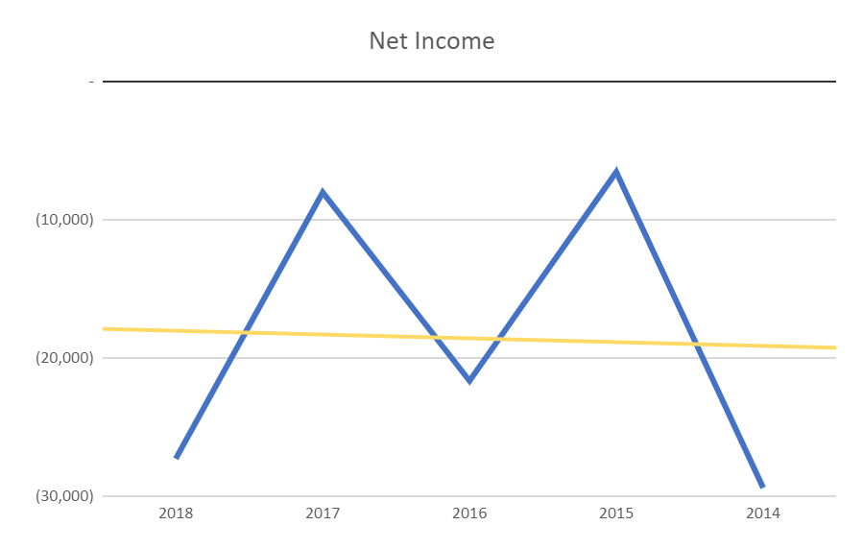

From our financial reporting, it seemed Ballard were on a steady rise, at least with regards to their stock price. So, this is a noteworthy change in direction for their financial standing. However, a fairly flat increase in total revenue doesn’t seem surprising, considering our analysis showed an almost flat increase in net income over the 5 year period. As well as a significant drop in revenues from 2017 to 2018, even though over all, the past 5 years have seen increases in revenue. The change from a decrease in revenue to an increase from 2018 to 2019, is clearly an improvement, so Ballard have done something to correct the issue in revenue we noticed.

Article link: <https://www.fool.com/investing/2019/10/31/why-ballard-power-stock-just-dropped-7.aspx>

## Historic Strategic Collaboration - Weichai Power and China Strategy

In 2016, Ballard formed a strategic partnership with Zhongshan Broad-Ocean Motor Co., Ltd. of China. A joint venture with Guangdong Nation-Synergy Hydrogen Power Technology Co. Ltd was formed to manufacture fuel cell stacks in china. This partnership with Broad-Ocean and joint venture with Guangdong Nation-Synergy facilitated the development of 300 fuel cell buses, and deployment of twenty-two more in china. The event was significant for Ballards growth in the industry. As of August 2018, Ballard partnered with Weichai Power which included an equity investment of $163 million (19.9%) and a commitment of 2,000 fuel cell commercial vehicles. This is the largest deployment of fuel cell vehicles in history. Broad-Ocean was brought into the agreement and purchased a sufficient amount of shares to maintain 9.9% ownership of Ballard. Broad Ocean, and Weichai, contributed equity worth $183 million and helped bring forth the fuel cell technology being used in China today. Ballard’s stock bumped up $0.64 on August 29th after the deal was announced. It continued to go up in September of 2018, only to return to pre-Weichai collaboration prices in November of 2018. These collaborations helped prove Ballards commitment to leading the charge in global clean energy. All contributing to the China strategy and bringing power house energy companies together to accomplish one goal, clean energy for all. 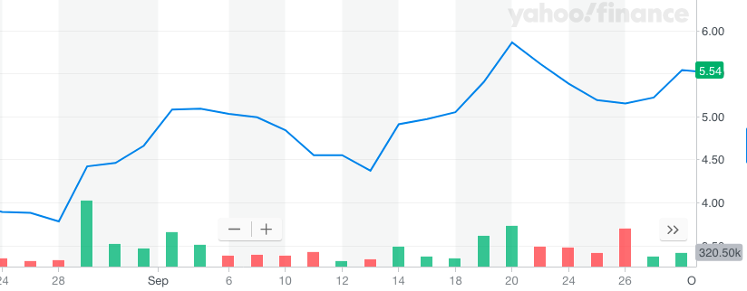

Article link:

<https://www.ballard.com/about-ballard/newsroom/news-releases/2018/08/29/ballard-signs-historic-strategic-collaboration-with-weichai-power-advancing-china-strategy>

# Financial Statements

## Income Statement Analysis (Horizontal and Vertical)

The previous full 5 years of financial statements, being 2014 to 2018, for Ballard Power Systems was analyzed. Over that time frame, Ballard has had a steady increase of most of their key financial attributes, with a few key differences. When looking at the horizontal analysis of their income statements, they’ve had an average increase of about 46%, over the 5 year, of their contribution margin. This indicates they are increasing the profitability of the products and services they sell. In contrast however, they have also seen an average of about a -153% decrease in net income over the same time. This indicates they have some issues with their financing and fixed expenses that are depleting their gross income. When looking at the vertical analysis of their income statements, they average 25.19%

While inspecting the vertical analysis of Ballard’s income statements over the past 5 years, it’s clear they are not making enough revenue to cover their expenses. They have an average net income of -22.96% of their revenue over the 5 years. Their costs of goods sold is an average of 74.8% of their revenue which only leaves about 25% to cover the entirety of their fixed expenses, financial expenses, and income taxes. That has however, been on the decline recently as it’s gone from 85.09% in 2014 to 69.28% in 2018 That is why though they have had a negative percentage for their net income every one of the past 5 years. However, the positive that results from this is that Ballard has been able to use a tax shield and have only paid an average of 0.62% of their revenue to taxes. This is a major factor as to why Ballard has not suffered more over the last 5 years. Another thing of note, was that in 2018 the loss of investment in joint ventures and associates was only 1.19% of revenue. That was what their CEO attributed to their lower than predicted performance in 2019 to, so it must have drastically increased in 2019. It has been on the rise as of the previous two years but the average over the 5 years was 0.42% only.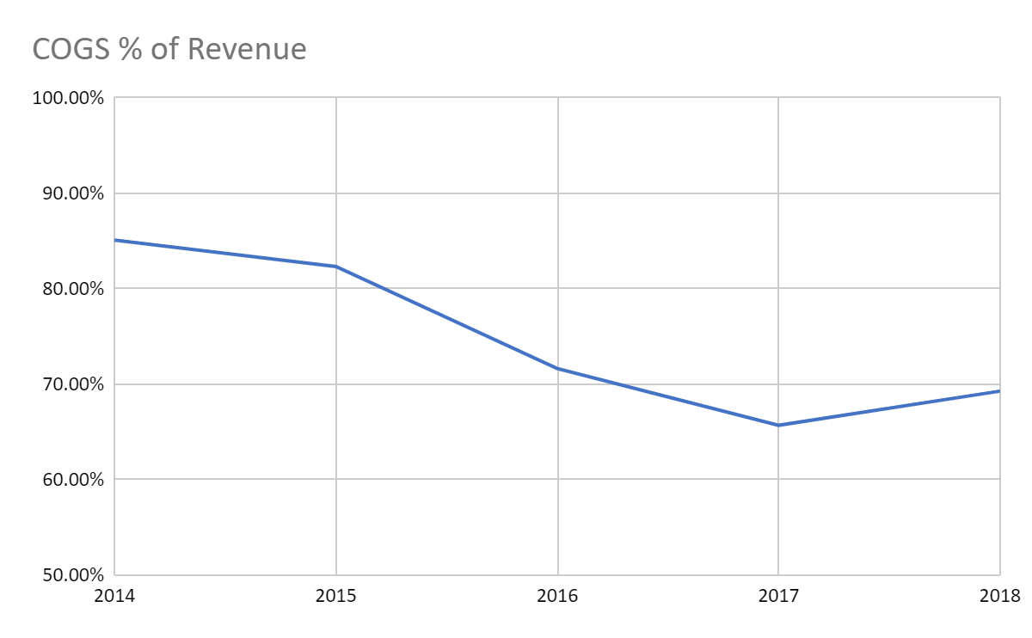

## Balance Sheet Analysis **(Horizontal and Vertical)**

For Ballard’s horizontal balance sheet, their total assets increased significantly with a slight drop from from 2016 to 2017 and the same trend applies for their total liabilities and equity. Ballard has an average increase, over the 5 years, for total current assets of 61.45% and for non-current assets 32.86% while they only has an average of 19.11% and 7.45% for its current liabilities and total liabilities. That means Ballard doesn’t depend much on debt to finance their capital. Ballard also has an average of 46.04% for its equity in which foreign currency reserve has the highest rate of 93.68% in Ballard equity.

Within Ballard’s current assets, cash and cash equivalents account for the highest percentage of total assets where the average change throughout 5 years was 34.48%. While in the non-current assets goodwill and intangibles assets have the highest value on Ballard’s total asset with an average of 22.02% and 10.27% respectively. For the liability side, trade and other payables account for the highest value of Ballard current liabilities with 10.10% and the same goes for its finance lease liability with 3.97%. Within equity, share capital and accumulated deficit were likely the main focuses of Ballard with 546.08% and -639.14% respectively.

## Balance Sheet Ratios

The Balance sheet ratios show a complete overview of how Ballard systems inc. is doing overall. It shows the relationships of the financial information over the last 5 years. Most importantly, Ballards Current ratio took a big spike in 2018 from 2.61 to 5.48 along with its quick ratio from 2.17 to 4.87. This shows that Ballard might be meeting it’s short term obligations and that it is in its growth stage, although this does not mean much in the long term. The profit margin has been negative over the last 5 years from as low as -42.68% in 2014 to as high as -6.64% in 2017, either way they have not been able to make a gross profit. This could mean that they are relying heavily on investments and paying heavy production costs.

The ROE and ROA have also been on the negative side throughout the previous 5 years but have still been making improvements. In 2014 The ROE was as low -37.14% and the ROA was -23%. These are some heavy losses but they have managed to increase the ROE and ROA up to -9.67% (ROE) and -7.89% (ROA). Either way, this means the shareholders are not getting the return they want and this might make them give up on the company because of these red flags. Ballards receivable turnover has been okay in a few years sitting at 5.23 in 2014, 5.71 in 2016 and 5.26 in 2017. It has also been fairly low in 2015 at 2.22 and has gone back down in 2018 at 2.28. This is another red flag for the company because it could mean that they are not financially viable and have issues with credit policies, problems with collection etc. The collection periods have all been quite long to go along with it.

Something positive about Ballards balance sheet ratio is that they have managed to keep their Debt-to-Total-Assets ratio below 1. The highest it has gone was in 2014 at 0.38 and as recent as the public knows, it has been as low as 0.18 from 2018. This is a good sign because it shows that they are not funding they are holding higher assets than debt and have been able to fund their debt obligations.

## Comparatives

Comparatively Ballard is a first mover in the fuel cell industry. They have made pushes into the Chinese market with a partnership to Weichai in 2018. A large part of the worlds fuel cell shipments comes out of Asia and with their local partners having already committed to 2000 commercial fuel cell vehicles Ballard has the capacity for higher growth than their competitor Nuverra. They are also at an advantage compared to Nuverra since the field of fuel cells is not as saturated as the oil energy sector is and also enjoys much support from the federal government. Bloom energy is comparatively in a strong position though as they seem to have received heavier invest and are partnered in more projects with other companies. But Ballard has the advantage of having been in the industry for far longer and having the experience to back it up. With their current partnership trend while Ballard growth is not as explosive as Bloom’s it seems to have more staying power than Bloom’s according to their stock fluctuations.

## Cash and Shareholder’s Equity

Ballard has seen a net loss in operating activities for the past five years. Ballard’s operating cash usage was high in 2018 ($31.688 million). At the same time their net operating loss was $27.323 million. A similar loss happened in 2014. This is not necessarily indicative of unhealthy spending. The majority of their loss comes at the expense of investing in new technology. Ballards losses come from joint venture and associate investments. Renewable energy is an emerging industry and is still in its infancy in terms of innovation and return on investment. Financing activities place Ballard in handcuffs as they are constantly leveraging their assets to finance more capacity. This renewable energy company is in a growth period and rightfully so. Renewable energy is arguably the most important growth industry currently and requires significant cash flow to operate. 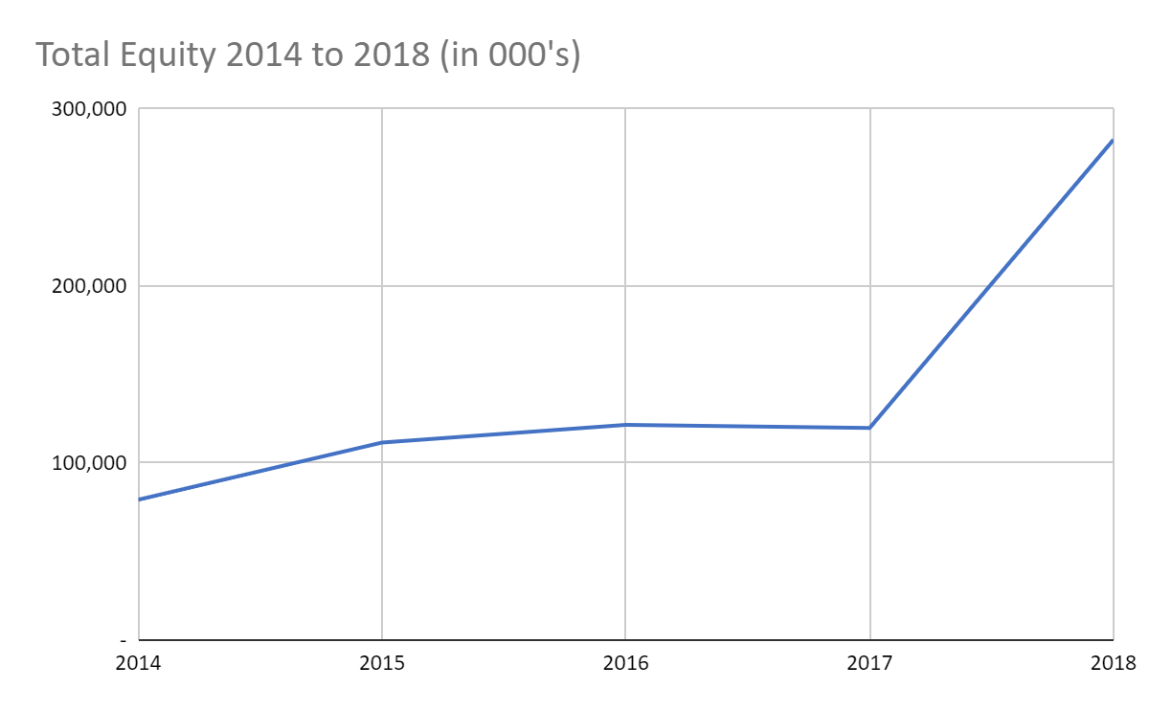

Ballards equity is owned by energy companies with similar interests. For example Weichai Power (19.9% percent) and Broad Ocean (9.9%). (Joint venture agreement 2018) Ballards equity has consistently increased over the past five years showing Ballards propensity to finance through equity. Ballard attracts equity investors through their own investments. For example, net income represents 9% of Ballard contributed surplus. Therefore, investments take priority for Ballard and keep them alive.

## Operating Leverage

Ballard Power Systems Degree of Operating Leverage has been decreasing over the years. In 2014-2015, the company's DOL was 0.63 and has only decreased year by year. In 2015-2016, Ballard Power System was -0.54, then in the following year (2016-2017) the operating leverage decreased to -1.73 and finally in 2017-2018 the company’s DOL is at a surprising -16.03. The company's DOL took such as dramatic decrease in 2017-2018 because the company's revenue decreased by -24.702$ and the EBIT incrementally increased by 15,921$. The company’s low DOL demonstrates and reflects the company’s variable costs. An example of this can be labour costs; and how the increase in labour costs due to employees being hired can have an affect a company’s DOL is regards to lowering the operating leverage. Furthermore, A negative or low DOL means the company’s EBIT is higher or not far behind the company's sales revenue, which is not a good sight for an investor and can mean the company will soon shut down because they are not performing well and may not have enough revenue to pay for their fixed and variable costs. In addition. a company with low operating leverage proportion of variable costs-which means that it earns a smaller profit on each sale, but does not have to increase sales as much to cover its lower fixed costs(Hayes, 2019).

# Stock Analysis

## **Price for the last 5 years**

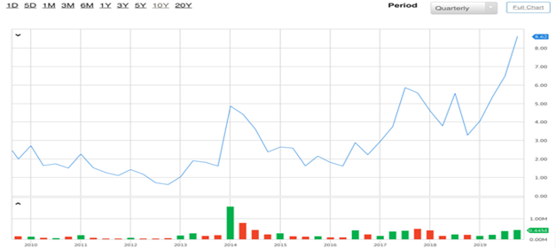

· Source: (The Globe and Mail, 2019)

## Stock price for last year

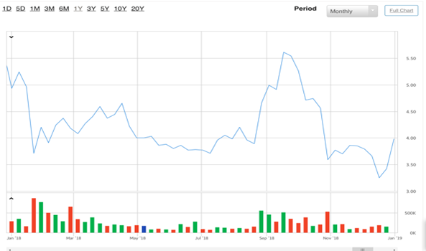

Source: (The Globe and Mail, 2019)

**Stock price for last 3 months**

(Source: Yahoo Finance, 2019)a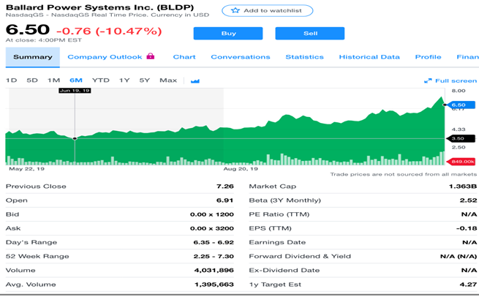

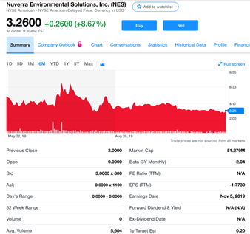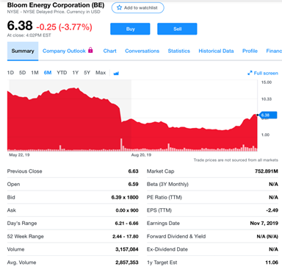

(Source: Yahoo Finance, 2019)c (Source: Yahoo Finance, 2019)b

## Benchmarking

When Comparing Ballards to its rivals, Nuverra and Bloom Energy, it can be seen that Ballard has better performance when it comes to its share price. Their valued at $ 6.5 (8.62 CAD) per share, which is more than Nuverra at $3.36 per share and Bloom Energy’s at $6.38 per share. Looking at the trend analysis, however, Ballard’s share price hasn’t fluctuated as much as its rivals has recently. In addition, we can see that Bloom Energy has better performance to their share price than Ballard. Over the last 6 months Bloom’s highest rate was approximately $14.65 per shares even though they experienced a drop in their share price. In general, Bloom Energy seems to have a better growth rate than Ballard. In contrast, Ballard has a better EPS than both their rivals with -$0.18 per share compared to Nuverra’s -$1.77 per share and Bloom’s -$2.49 per share that means Nuverra and Bloom lose more money than Ballard on each share they have issued. Also, Ballard has a better value of market cap than its rivals at 1.363 which can attract investors easier and effective because market cap reflects the size of the company.

With regards to the stock price changes, a negative EPS value also affects the changes in stock value since negative EPS means companies are operating at a loss. A net loss will decrease the value of their stock thus lowering its price from the decrease in demand of that stock. In addition, Ballard’s stock price increasing significantly may be due to the need of society for electric or hydrogen fuel-cell vehicles as well as the wide-scale adoption of hydrogen fuel cells is coming as a revolution of transportation. That helps Ballard to be able to attract more investors which can also increase its stock price (Pearson, 2019). Moreover, an investment and partnership which came from China also contributed to the higher value of Ballard’s stock. Weichai Power bought a 20% stake, for $163 million, of Ballard Power Systems which helps Ballard to be able to penetrate the highest potential vehicle market, hydrogen fuel cells (Pearson, 2019).

# Overall Evaluation of Company Performance & Conclusion

Ballard Power Systems has overall been in the black for the previous 5 years, however they seem to be on the rise. With good signs in the decrease of their percentage of revenue for their costs goods sold to their superior performance on the stock market than their competitors. As well as their strategic moves when it came to their sale of stock to Weichai Power for an investment of $163 million, and the market of hydrogen fuel cells being predicted to keep increasing into the future as well, These factors show Ballard is investing in their future as they see their business playing a large role in the energy sector well into the future.

# Recommendations

1. Keep Focused on increasing profitability
   1. A continued negative net profit is just not sustainable. Ballard has shown improvements along their production and value chain, and have secured some investments from other companies to combat a negative net income. They need to keep focusing on increasing their contribution margin and lowering fixed costs, potentially through their partnerships and investments, so that they can end with a positive net income. If the hydrogen fuel cell market does become a powerhouse, as expected, Ballard needs to focus on staying afloat until that does happen. Therefore with an increase of investments in their company and a decrease of variable and fixed costs, they can achieve this.
2. Enter the Korean market
   1. Korea has higher fuel cost in comparison to other major players in energy countries. Korea is advancing fuel cell technology because of lacking resources. Ballard competitor Hydrogenics has already made the move into the Korean market to fill the innovation gap. South korea’s 2018 GDP was upwards of 1.5 trillion (world bank) and their mining contribution to GDP was 457 billion. (trading economics) It’s important to note resources being mined in Korea are not contributors of combustion engine technology. Additionally, Samsung makes up 15% of South Korea’s GDP making the country an official tech leader. (Pham, P. 2018)
3. Keep costs at a minimal

Ballard Power Systems just recently sold 20% of their company; therefore, Ballard Power Systems can utilize their partners in regard to gaining information about the supply chain and ways to decrease costs. In addition, Ballard can partake is deals and agreements to further lower variable costs.

# Appendix

## Income Statement

## Balance Sheet

## Cash Flow Statement

## Ratios

## 

# 

# References

Ballard.com. (2019). *Our Vision | Global Clean Energy Solutions | Ballard Power*. [online] Available at: <https://www.ballard.com/about-ballard/our-vision> [Accessed 24 Oct. 2019]

Ballard Power Systems. (2019, October 13). Retrieved from <https://en.wikipedia.org/wiki/Ballard_Power_Systems>

Hayes, A. (May 21, 2019). Understanding the Degree of Operating Leverage. Retrieved November 28, 2019, from Investopedia website: <https://www.investopedia.com/terms/d/degreeofoperatingleverage.asp>

Peason,O. Natalie. (2019). After 40-year Losing Streak, Fuel-Cell Maker Shares are Soaring. Retrieved from<https://finance.yahoo.com/news/40-losing-streak-fuel-cell-040100541.html>

Smith, R. (2019, October 31). Why Ballard Power Stock Just Dropped 7%. Retrieved November 21, 2019, from The Motley Fool website: <https://www.fool.com/investing/2019/10/31/why-ballard-power-stock-just-dropped-7.aspx>

The Globe and Mail. (2019). Ballard Stock Price Summary. Retrieved from<https://www.theglobeandmail.com/investing/markets/stocks/BLDP-T/full-chart/>

Yahoo Finance. (2019) a. Ballard Stock Price. Retrieved from<https://finance.yahoo.com/quote/BLDP/news?p=BLDP>

Yahoo Finance. (2019) b. Nuverra Environmental Solutions Stock Price. Retrieved from<https://finance.yahoo.com/quote/NES?p=NES&.tsrc=fin-srch>

Yahoo Finance. (2019) c. Bloom Energy Corporation Stock Price. Retrieved from<https://finance.yahoo.com/quote/BE?p=BE&.tsrc=fin-srch>

South Korea GDP. (n.d.). Retrieved November 28, 2019, from <https://tradingeconomics.com/south-korea/gdp.>

Pham, P. (2018, May 31). What Is South Korea's Secret Weapon? Retrieved November 28, 2019, <https://www.forbes.com/sites/peterpham/2018/05/31/what-is-south-koreas-secret-weapon/#55d8bd8a6b2f.>

WORLD DEVELOPMENT INDICATORS. (n.d.). Retrieved November 28, 2019, from <http://datatopics.worldbank.org/world-development-indicators/.>