Fuel Café
Media Portfolio
Emma Giesbrecht, Haritima Singh, Jaskaran Kaur, Kim Kasirer
2018
MEMORANDUM

To: Eleanor Watson
From: Emma Giesbrecht, Haritima Singh, Jaskaran Kaur, Kim Kasirer
Date: April 10, 2018
Subject: Proposal for promotional yoga workshop

Dear Eleanor Watson:

It is our pleasure to provide you with our proposal to host a promotional yoga workshop to raise awareness of your company and increase retention of previous customers.

Following your requests, I have included many of the plans for the event, as well as required costs and measurements of success. Advanced planning and preparation is crucial for large events such as this one, and we will be pleased to assist with the process as we are needed. The following proposals includes:
- The details of the event,
- The benefits to be gained,
- The challenges included,
- The costs associated,
- The methods of measurement of success.

We believe this event will achieve your goal of increasing customer awareness and retention of previous customers through its approach. Please contact us within two weeks to arrange a meeting in person to discuss any questions or concerns you may have, as well as finalize the details of the workshop and budget. We can be reached at (604) 863 8974 or by email at ehjk@collab.ca.

Yours truly,
Emma Giesbrecht
Emma Giesbrecht

Contents
INTRODUCTION 5
BACKGROUND 5
WHO WE ARE 6
Emma Giesbrecht 6
Haritima Singh 6
Jaskaran Kaur 6
Kim Kasirer 7
THE PROPOSAL 7
Details 7
Benefits 8
Challenges 8
Costs 8
Measuring Success 9
CONCLUSION 9
APPENDICES 10
Appendix A: Brochure 10
Appendix B: Media Release 11
Appendix C: Marketing Letter 14
Appendix D: Rational 17

INTRODUCTION (intro)
We are writing to propose Fuel Café host a promotional yoga workshop to raise awareness of the company. The company is currently facing difficulty standing out from the older, more well-known health food locations, and we believe hosting an event encouraging health and wellness will be beneficial to both the community and to Fuel Café. (current situation)

BACKGROUND
In March 2018, Eleanor Watson, owner of Fuel Café, approached our team to create a successful plan for the following season. She indicated a desire for an expanded customer base and retention of previous customers. The proposal was to cover our recommended actions and all outcomes of implementation.
As you are aware, Fuel Café provides customers with healthy, organic, locally-grown food and smoothies. It allows for full customization of items on the menu, giving customers thousands of possible meals. Customers also have the opportunity to learn about and try any superfoods simply by requesting a sample. It is the best location to visit for a healthy meal or drink, able to accommodate all palates and cravings. (fanning, evidence of research) It has been in operations for just over a year and has gained many customers in that time; however, an increase in customer base and retention will be required in the next year of operations.
We have assisted many companies in similar positions in the past, and all have seen dramatic increases in their desired areas with our assistance. (track record) It is with this experience that we present this preliminary proposal of a marketing plan for Fuel Café for your consideration.

WHO WE ARE (WEAPY)
Emma Giesbrecht - I am a first-year student at Capilano University, studying to receive a Bachelor of Business Administration. I was introduced to accounting in my last year of high school and immediately knew that was my passion; I therefore applied to Capilano University with the intention of becoming a Certified Professional Accountant. In my time at university I have completed many courses in other areas and have found the majority of marketing to be closely linked. It is with this knowledge that I act as a business consultant, working to help companies reach their full potential.
Haritima Singh - I am an international second-year student from India. I always wanted to study abroad so that’s the only thing I asked for after graduating from high school. I came to Canada alone almost a year and a half ago. I pursued Business Administration program because I took Commerce in high school and was really good at Accounting. Initially, I wanted to major in Accounting because I was good with numbers. But in my first year, I took various Business courses and electives and found out that I liked everything about the Business program. However, marketing and accounting are the two things that I absolutely love! So, I decided to be a business consultant and help people improve their companies. I help them with the market research and offer recommendations and suggestions to local businesses to help them succeed.
Jaskaran Kaur - I am a second-year student in Capilano University. I am studying business administration diploma program because I like accounting and business courses. I am an international student from India and I came to Canada in the month of November 2016. I was very excited to study in university. In my high school, I loved business and wanted to become a business consultant; however, after studying accounting in Capilano I liked numbers a lot. Then, I decided to be a Chartered Professional Accountant. I am planning to do major in accounting and find a part-time job as a teller in a bank to get more knowledge about accounting on computers.
Kim Kasirer - I am a third-year student at Capilano University, currently completing my Bachelor of Business Administration, specializing in Marketing. I started my studies at Langara College, where I explored different options and made the switch to the business program, later transferring to Capilano University. Being passionate about entrepreneurship, business management and marketing has brought me to becoming a business consultant, where I can put my passion to work and help put companies on the right path, achieve their goals and objectives, and see results.

THE PROPOSAL

Details
Health and fitness are growing trends in Vancouver, and with summer on its way now is the perfect opportunity to hold a workshop promoting them. (window of opportunity) The event should be held in the afternoon on Sunday, July 8, 2018 at Yyoga Downtown Flow to allow for the greatest turnout possible.
The event should include several yoga instructors to allow for a more personalized experience, as well as holistic nutritionists to answer questions regarding health. A salad and drink bar will be provided throughout the entire event for attendees to enjoy as they wish, featuring Fuel Café’s top products. A draw would be conducted, with the winner receiving a free yoga mat and meal-planning consultation. Fresh, organic produce will be available for purchase separately for those interested in making their own meals, as well.
Previous frequent customers will receive a complimentary ticket to attend the event to promote loyalty from both sides.
An updated brochure should be available to attendees, highlighting the company features, values, and offers. An outline of a brochure can be seen in Appendix A.
Event media release and marketing letter can be seen in Appendix B and C accordingly. The rational behind these features can be seen in Appendix D.

Benefits
Hosting this event will lead to an increased awareness of Fuel Café, resulting in new customers, and retention of previous customers. Ensuring the loyalty of customers is crucial, as they contribute the most to profits of a company which will allow it to flourish in the coming future.
The workshop will also teach attendees about the products and missions of Fuel Café, which will encourage new customers to visit the location and try additional items from the menu.
Challenges
While there is much to be gained by hosting a large promotional workshop, it requires a lot of money and time. One of the greatest challenges associated with the event include obtaining a partnership with Yyoga, an established company, and using its facilities; advanced contact and mutual opportunity will allow both parties to benefit from such a partnership.

Costs
Costs associated with hosting a yoga workshop include:
- Printing new brochures and marketing letters
- Reserving newspaper space
- Providing a complimentary salad and drink bar
Revenues from the event include:
- Entry ticket sales
- Draw ticket sales
- Produce sales (bullets)
Profits from entry ticket sales and 20% of proceeds from produce will be donated to the Greater Vancouver Food Bank (GVFB).

Measuring Success
The event will be known to be successful monetarily if the goal amount of $10,000 is donated to the GVFB. Customer loyalty can be seen through the percentage of customers who redeemed their free tickets. Other measurements include an increase in customers by 45%, and app users by 60% throughout the summer season. These can be determined early September through simple dashboard statistics with Analytics Co.

CONCLUSION
Hosting a promotional yoga workshop in partnership with Yyoga will be able to increase Fuel Café’s customer base by 45% throughout the summer season, as well as encourage customer loyalty and retention.
Please contact us within the next two weeks to set up a meeting in person to discuss any questions or concerns you may have, as well as finalize the details of the workshop and budget. (face to face) We can be reached at (604) 863 8974 or by email at ehjk@collab.ca.

APPENDICES

Appendix A: Brochure



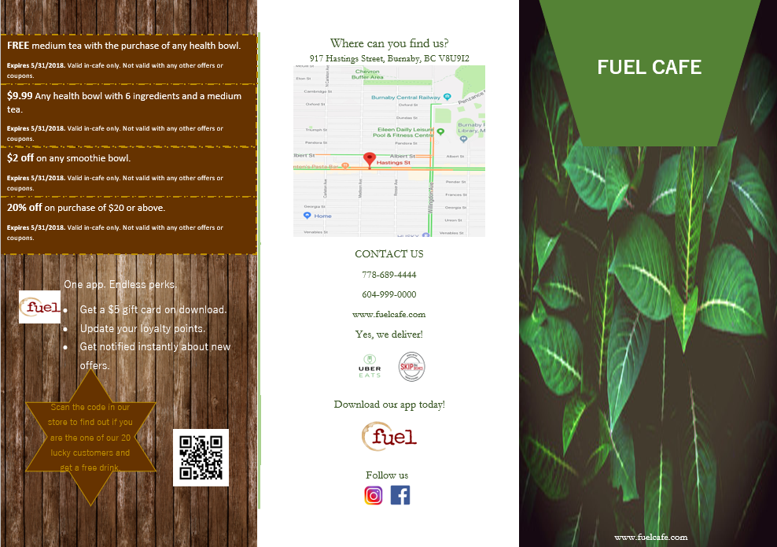

Appendix B: Media Release
Fuel Cafe
917 Hastings Street
Burnaby, BC V8U9I2
Media Release

April 10, 2018 (date)
For Release May 15, 2018 (release info)

Contact: (contact info)
Eleanor Watson, Owner
778-689-4444
info@fuelcafe.ca

Start Your Summer in Tree Pose

Fuel Cafe is going to kick off summer with a yoga workshop that will take place at Yyoga Downtown Flow on July 8, 2018. (Who, What, When, Where) This workshop will introduce attendees to an alternative method of staying fit and increase awareness of the benefits of a healthy lifestyle. (Why)

There will be yoga experts on-site for providing proper guidance and personal recommendations beginning at 12:00pm. Moreover, a complimentary salad and drink bar will be on the premises, along with information about how organic products are grown and supplied from the producers and suppliers themselves.

According to Jake Leighton, certified holistic nutritionist, “a healthy journey begins with a healthy attitude and an open mind.” (quote) Fuel Café and Yyoga are partnering to help you kickstart your journey the right way.

The event will have an energetic start with an upbeat, easy-to-follow yoga routine for all attendees to partake in. At the salad bar, which will be open for the duration of the occasion, experts will be available for discussions about healthy eating and sustainable goals. Yoga mats and fresh, organic produce will be available for sale, and there will be a draw at the end of the day for a free yoga mat and meal-planning consultation. (details)

The entry fee for the event is $25 per person over 16 years and $15 below, with available student discounts at $20. Full profits from the event and 20% of revenue generated from the sales of fresh products will be given to the Greater Vancouver Food Bank (GVFB). Aart Schuurman Hess, CEO of the GVFB, will speak at the event, explaining the organization’s purpose and the use of the donation. (Corporate Social Responsibility) The goal is to supply $10,000 to those requiring use of the food bank. (goal)

About the Companies:
Fuel Café works to allow people to live better by both eating healthy and loving what they’re eating. It is truly passionate about paving the way for a focus on foods your body will love, instead of what it should avoid. This means spending less time and energy on decision-making, and a lot more time to utilize in your everyday life. (mission statement)

At Yyoga, they are dedicated to creating communities that bring yoga and fitness to anyone seeking a healthy, balanced life. They believe that through movement, they ultimately create happier, healthier people, connected to themselves and others.

For more information, please contact:
Eleanor Watson, Owner
778-689-4444
info@fuelcafe.ca

[Note to Editor: photos and special press opportunities for interviews/photographs/videos available] (note to editor)

Attns: itinerary for press use (attachment)
-30-

Appendix C: Marketing Letter
917 Hastings Street
Burnaby, BC
V8U 9I2

May 10th, 2018

4849 Woodland Drive
Vancouver, BC
V6H 3M2
jackhallman@gmail.com (email/address)

Dear Jack Hallman, (top tier customers)
Because you’re a valued Fuel Cafe customer, we would like to offer you free entry to our upcoming summer kickoff yoga workshop, where we will offer both a group and personalized yoga experience. Along with this, there will be a complimentary salad and smoothie bar and our products for sale. (gain attention) All regular ticket proceeds and 20% of product sales will go to the Greater Vancouver Food Bank, a cause we are truly passionate about.
To redeem your free ticket(s), simply contact us at info@fuelcafe.ca with your RSVP and the ticket(s) will be delivered to you. (ease of contact/payment)
We at Fuel Cafe would also like to offer you a complimentary smoothie or salad customized by you, at your next visit to our cafe. As a whole-food lover, you know it can be very challenging to find wholesome ‘fuel’ options on the go. Even more challenging can be finding a truly affordable option, instead of settling for the price tag. (resonance, gain interest)
By providing the public with transparency and value, we aim to redefine healthy options on the go. You can finally find superfoods such as kale and quinoa at an affordable price and conveniently; and no, it doesn’t cost extra.
Some of the new nutrient-packed superfoods and ingredients we offer:
- Kale
- Quinoa
- Spinach
- Lentils
- Spirulina
- Goji berries
- Hemp seeds
- Chia seeds
- Flaxseeds
- Wheatgrass (bullets)
We are genuinely passionate about allowing people to feel and eat the best. This is a mission we have embarked on due to our own struggles with being on the go and maintaining a healthy diet, without having to compromise knowing what is in the food we eat, affordability or convenience.
Our menu is customizable and constantly evolving, whether you’re a vegetarian, vegan or eat meat. Our in-house holistic nutritionist researches, tests and tastes on a regular basis, and we find ways to bring them to you. In addition, we always welcome your special requests or feedback – found an intriguing superfood you want to try without committing to including it in your grocery list? Want to try a new flavour, ingredient or combination? We can help. We provide free samples of each ingredient we offer – from beverages to food, so that you are able to see what works for you. Every option is customizable according to your own preference, at no added charge.
Our mission? To make it easier for people to live better by both eating healthy and loving what they’re eating. We are truly passionate about paving the way for a focus on foods your body will love, instead of what it should avoid. This means spending less time and energy on decision-making, and a lot more time to live your best life. (short paragraphs)
Sincerely,
Eleanor Watson
Eleanor Watson
Owner
Fuel Café (signed by owner)

P.S. If you download our app ‘Fuel Cafe’ today, you can immediately be eligible for a free customized smoothie or juice in-store, order in advance for pick-up or delivery via Uber Eats and Skip the Dishes, and view all nutritional information and menu items. (afterthought, motivate action)

Appendix D: Rational
Brochure:
The brochure is designed to attract new customers with deals and information. It informs them of what the company has to offer, what it believes in, and where it is. The brochure should be located in an easy-to-see location in-store regularly and at future promotional events. Some of its features include:
- A loyalty program for customer retention,
- Coupons to attract new customers and promote extended use of the brochure,
- A map providing the location of Fuel Café
- Colour, pictures, and eye-catching captions to draw attention toward the brochure,
- An ‘About Us’ section to inform new customers of the company’s beliefs and missions.

Media Release:
The media release will inform the public of the upcoming promotional yoga workshop and create excitement regarding the event. This will be released mid-May to ensure it is not forgotten, but there is ample time to purchase tickets and clear the day. Features include:
- A catchy headline to draw attention toward the article,
- A goal for the public to help the company reach and to support,
- Event details to create excitement and interest,
- Corporate Social Responsibility to show the positive impact the company has,
- A quote to confirm knowledge, and increase interest and reputation,
- The Mission Statement for the public to understand the company’s goals and beliefs.

Marketing Letter:
The marketing letter will be sent directly to previous customers that have shown impressive loyalty toward the company. They will receive exclusive offers to thank them for their devotion and encourage it in the future. This includes:
- Personally addressed to top tier customers to show appreciation,
- Attention-grabbing promotion to encourage further reading,
- Ease of contact to encourage participation and communication,
- Short paragraphs for ease of reading,
- Signed by the owner personally to show importance of customer.

