Business Plan
Elixir Cleaning
201-132 15th Street West
North Vancouver, V7M 2N5

BADM268 – Spring 2022

April 11, 2022

Prepared by:
Jianfeng Chen
Chief Executive Officer
David Xiong
Chief Operating Officer
Piyush Mittal
Chief Marketing Officer
Farzad Moayedi
Chief Financial Officer
Table of Contents

Executive summary 3
Business overview 4
Project objective 4
Business description 4
Products and services 4
Key people 4
Risk assessment and contingency plan 4
Operations plan 5
Business location 5
Equipment 5
Technology 5
Environmental compliance 5
Advisory team 5
Key employees 6
Service process 6
Market research 7
Market size and growth 7
Competitive environment 7
Industry research 7
Marketing strategy 7
Product, Promotion, Plan, Price 7
Marketing costs 8
Marketing tactics 8
Financial plan 9
Sales level 9
Financial needed 9
Investment 9
References 10
Appendix 11

Executive summary
Project objectives

Establish a cleaning and disinfecting service providers limited liability partnership corporation in 2022.
Become the best and professional cleaning and disinfecting service provider in British Columbia.
Business description
Develop technology to connect customers for convenient on making appointment by one-click.
Cleaning supplies are quality assured and cleaning services are provided by dedicated and meticulous staff.
Located in North Vancouver, BC.
Training plans in service and ethics are well-developed.

Products and services
- Office, janitorial, carpet, floor, upholstery, appliance, and pressure washing for restaurants and hotels.

Key people
Jianfeng Chen, Chief Executive Officer (25% ownership): 24-years-old. More than 5 years experience in business administration and economy. Main responsibilities: Strategy decision making.
Piyush Mittal, Chief Marketing Officer (25% ownership): 24-years-old. More than 5 years experience in marketing industry. Main responsibilities: Marketing, marketing research, marketing campaigns.
Farzad Moayedi, Chief Financial Officer (25% ownership): 24-years-old. More than 5 years experience in financial planning. Main responsibilities: Rasing funds, purchasing, sales invoicing.
David Xiong, Chief Operating Officer (25% ownership): 24-years-old. More than 5 years in human resourcing. Main responsibilities: Overseeing daily operations and administrations of a business.
Risk assessment and contingency plan
Risk of Covid-19 infection
-Provide sufficient and efficient protective products.
-Inform the up-to-date information of preventing infection.
-Sanitizing guarantee and vaccinated proof for customers
Shortage of skilled cleaning people
-Well-developed trainings
01.

Business overview

Business description
Develop techonology to connect customers for convinent on making appointment by one-click.
Cleaning supplies are quality assured and cleaning services are provided by dedicated and meticulous staff.
Located in North Vancouver, BC.
Training plans in service and ethics are well-developed.

Mission, vision, values
Mission statement: Clean to create a harmless environment to give a refreshing look.
Vision: The best and most reputable cleaning service provider.
Values: People, Service
People: A flat organizational structure allows employees to have prioritized rights to determine an optimized processing solution based on an actual situation. We will invest in employees' individual developments out of voluntary and mandatory will through different trainings. It equips employees with robust decision-making and leadership skills during services.
Service: We are service supervisors providing the best quality for our customers via platform feedback from customers to refine our services through the most up-to-date training.

02.
Operations plan

Business location
- Headquarter: 201-132 15th Street West, North Vancouver, BC.
  - Two floors and 795 ft².
  - Lease: direct type and $1,987 monthly.
- Office hours: 9:00 am to 5:00 pm from Monday to Saturday.

Equipment
- Cleaning supplies.
  - Stock in the storage room where our prime service staff access only.
- Product lifetime.
  - Quality ranging from medium to high as it will last for at least 5 years.
- Appropriate software system and APP databases.
- PPE equipment.
  - Provided for safety precaution.

Technology
- Website and app managements will be outsourced to a third-party company.
- Android and IOS systems friendly.
- Project initial stage costs: from $8,000 to $20,000.

Environmental compliance
- Nature Clean.
  - A local cleaning products company.
  - Sells chemical free and environmental free products.
- Comply with Hazardous Waste Legislation and Regulations.
- Waste will be properly packaged.

Advisory team
Jose Aldo
- Elixir Cleaning’s lawyer for the long term.
- Responsible for drafting legal documents and providing legal advices.

Key employees

 | Name | Key responsibilities | Title
1 | Conor Magrelo | Provide an exceptional Prime cleaning service to customers | Prime Service Member
2 | Floyd Mayrain | Provide an exceptional Prime cleaning service to customers | Prime Service Member
3 | Manny Pacming | Provide an exceptional Prime cleaning service to customers | Prime Service Member
4 | Canelo Almondega | Provide an exceptional Prime cleaning service to customers | Prime Service Member
Additional information
All Prime members are required to wear our dedicated high quality uniform, this ensures the safety, quality, and professionalism of all of our members. PPE equipment will be provided at all times of services.

Service Process
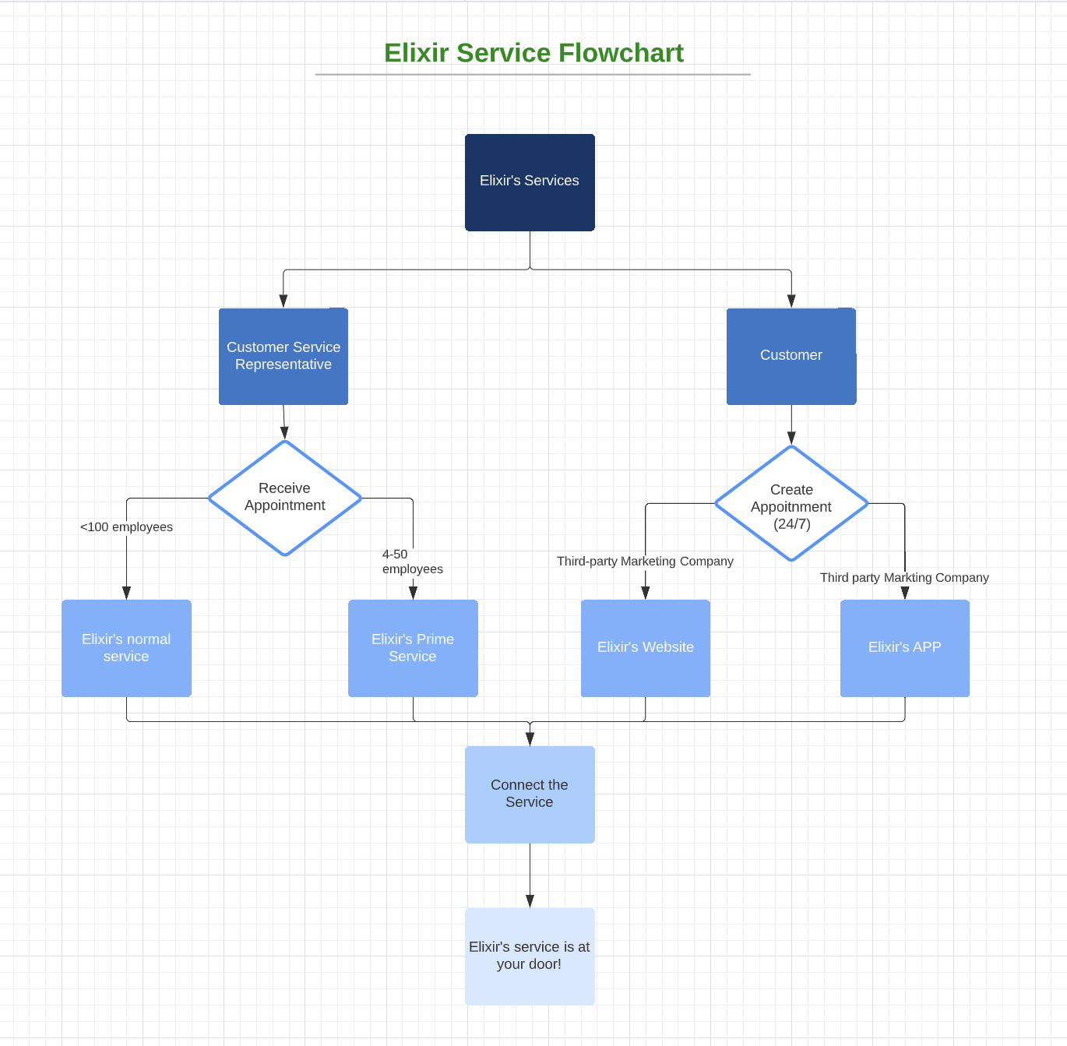
03.
Market research

Market size and growth
- 715 restaurants; 135 hotels; 25,000 guest rooms.
- The hotels and restaurants seek cleaning services from reputable companies by offering long-term contracts.
- With normalcy resuming, more hotels will be established, hence expanding the market size.

Competitive environment
- Relatively high competition industry.
- Stable companies and new entrants must employ competitive strategies to attract customers.
- Leading cleaning companies: AspenClean, Kirei cleaning services, Cleaning 4U, and EcoGreen.
  - Offer commercial and domestic cleaning.
  - Provide long-term or short-term services depending on customers’ needs.

Industry research
- Total available market: $8 billion
- Growth rate: 2.8% (between 2013 and 2018)
- Competitors: over 29,000 competitors
- Jobs available: 132,000

Marketing strategy
- Utilize technology-online platforms-to create awareness.
- Apply appropriate traditional mediums to reach traditional industries.

Product, Promotion, Place, Price
Product
- High-quality services to meet the customers’ tastes and preferences.
- Bundle selling.
  - Office, janitorial, carpet, floor, upholstery, appliance, and pressure washing.
Promotion
- Social networking.
  - Facebook and Instagram.
- Discounts – 30% off.
  - For the first service.
  - For downloading and signing up Elixir Cleaning’s application.
- Referrals.
- Google advertisements and event marketing.
Place
- Free training to attract a vast task force.
- Services will be delivered to where they are needed.
- Customers make orders through the company’s website, application, and phone calls.

Price
- Employ proper pricing strategies and make profits from its venture.
- Utilize penetration pricing strategy.
  - Using lower prices to attract customers to expand market share.
  - Draw clients from competitors.
  - Expected result: high sales which bring forth substantial profits.

Marketing costs
- Costs: $5,000.
  - Facilitate the marketing initiatives.
    - Reach potential customers
    - Google advertisements

Marketing tactics
- Open official accounts.
  - Facebook, Instagram, Twitter, and Others.
    - Posting pictures and videos related to the company’s activities.
    - Before and after photos will be shown to showcase the company’s prowess.
    - Respond to potential customers’ comments and inquiries.
- Print flyers.
  - Services offered, prices, and contact persons

04.
Financial Plan

Sales level
- Elixir Cleaning is in its launch phase where all the directors are working tirelessly to successfully launch the business. Currently Elixir doesn’t have any sales but we are working to generate around $ 180,000 within the first year based on the report in Appendix 3.

Funds needed
- We need to raise $150,000 for our three year operational plan. This money will ensure Elixir has a chance to take the proper steps towards establishing its customer base in the market within the first three years. We are planning to raise a portion of this amount from directors personal savings and allowing our close friends and families to have a chance and acquire a line of credit from a Canadian Bank. A cash flow table is in Appendix 4.
Investments
- We would need the money raised to aid in the operational aspect of our business. Having a pressure washer and vehicle to reach our prime customers’ needs is most vital. This amount will have minimal interest rate which allows our profit margin to stay healthy while maintaining all the share within the directors.

References
Bhattacherjee, U. (2021). 16 delicious Canadian restaurant industry statistics for 2021. Reviewlution. Retrieved April 8, 2022, https://reviewlution.ca/resources/canadian-restaurant-industry-statistics/
De Pelsmacker, P., Van Tilburg, S., & Holthof, C. (2018). Digital marketing strategies, online reviews and hotel performance. International Journal of Hospitality Management, 72, 47-55. doi.org/10.1016/j.ijhm.2018.01.003
Gurbuz, T., Albayrak, Y. E., & Alaybeyoğlu, E. (2014). Criteria weighting and 4P’s planning in marketing using a fuzzy metric distance and AHP hybrid method. International Journal of Computational Intelligence Systems, 7(1), 94-104. doi.org/10.1080/18756891.2014.853936
Harris, C. (2021, April 26). The 11 best cleaning services in Vancouver. The Best Vancouver. Retrieved April 8, 2022, https://www.thebestvancouver.com/best-cleaning-services-vancouver/
JANPRO. (2022). How big the commercial cleaning industry is in Canada. JANPRO. Retrieved April 8, 2022, https://www.jan-pro.ca/franchise-post/how-big-the-commercial-cleaning-industry-is-in-canada/
Bclaws.gov.bc.ca. 2022. Table of Contents - Hazardous Waste Regulation. [online] Available at: <https://www.bclaws.gov.bc.ca/civix/document/id/complete/statreg/63_88_00> [Accessed 9 April 2022].

Www2.gov.bc.ca. 2022. Hazardous waste legislation and regulations - Province of British Columbia. [online] Available at: <https://www2.gov.bc.ca/gov/content/environment/waste-management/hazardous-waste/legislation-regulations> [Accessed 9 April 2022].
201 - 132 15th Street West, B., 2022. 201 - 132 15th Street West, North Vancouver, BC | Office | For Lease | Spacelist. [online] Spacelist.ca. Available at: <https://www.spacelist.ca/listings/513279/bc/north_vancouver/for-lease/office/201-132_15th_street_west> [Accessed 9 April 2022].

Appendices
Appendix 1
 | Name | Key responsibilities | Title
1 | Conor Magrelo | Provide an exceptional Prime cleaning service to customers | Prime Service Member
2 | Floyd Mayrain | Provide an exceptional Prime cleaning service to customers | Prime Service Member
3 | Manny Pacming | Provide an exceptional Prime cleaning service to customers | Prime Service Member
4 | Canelo Almondega | Provide an exceptional Prime cleaning service to customers | Prime Service Member
Additional information
All Prime members are required to wear our dedicated high quality uniform, this ensures the safety, quality, and professionalism of all of our members. PPE equipment will be provided at all times of services.

Appendix 2
Appendix 3
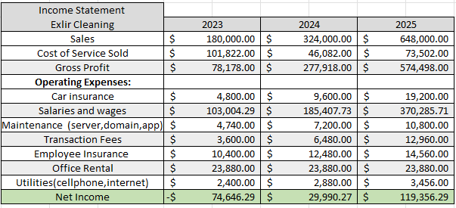
Appendix 4
