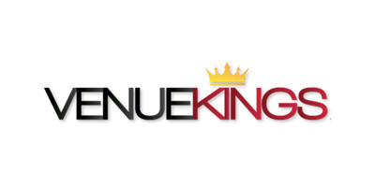

Capilano University

BADM 101 - 02

Date: April 4, 2018

By: Ali Golriz, Max Dong,Wenli Xu, Philippe Boppart, Thomas Cheong

**THE BUSINESS:**

**Description of Business:**

Venuekings was founded in 2009 during the 2010 Vancouver olympics and became a ticket broker that specializes in premium ticket inventory for events across North America. The founder of the company was Anthony Beytouti, a sport enthusiast, who bought his first group tickets in high school so he could attend a Vancouver Grizzlies game for his first time. Having tickets left over Anthony decided to sell the rest and therefore made his first sale as a ticket broker. When Anthony found out that the he had an interest in selling tickets he was able to turn his interest into a successful company. And now 9 years later, Venuekings has grown into one of the largest ticket broker companies, in North America.

Venuekings strives to help fans attend their favorite sporting events, concerts and live performances. They also offer a variety of tickets to MLB,NBA,NFL,MLS,CFL,concerts, theater and other sporting events.

The company's main goal and focus is to be one of the best in there industry and also to allow fans to enjoy the events and not to worry about the extras (VenueKings, 2018).

**Mission statement**:

Venue Kings strives to deliver the highest level of customer serves to all broker and customer while taking care of or responsibilities to the best of our abilities in a timely fashion. We will be leaders in the ticket broker community while being cutting edge in our techniques of efficiency. We will be leaders in the ticket broker community while being cutting edge in our techniques of efficiency (*personal communication,* March 2018*).*

**Business Goals:**

As what they claim on the website, there are 2 major goals they try to achieve and maintain.

* Firstly, they strive to help fans get the chance to attend many live performances, sports events and concerts with the best live experience by offering variety of tickets to concerts, theater, and other sports at the best stadium in North America. They are also seeking for the new markets so that they can give fans more chances to see more of their favorite and also provide even better service (Venue Kings, 2018)
* Secondly, they are always seeking for professionalism and customer satisfaction by providing 100% Buyer Guarantee. It means that once customers confirm your order, there will be a seat for them at the event no matter what happens. The tickets are guaranteed to be delivered to the buyers in time so that they will not be afraid of missing their events. If other cases do happen, then VenueKings ensure that customers will not endure any difficulties or losses (Venue Kings, 2018)

1. If the event is rescheduled, then the original tickets are still valid

2. If the event is cancelled, then customers will receive the full refund, even with the service and shipping fees.

**SWOT Analysis:**

|  |  |
| --- | --- |
| Strength   * 100% Buyer Guarantee * Experienced Founder * Provide various tickets in 3 different fields * Website is clear and easy to navigate * Easy to make orders | Weakness   * Buyers don’t know their seat number until they receive the tickets * There is possibility that buyers don’t get the exact seat * Lack of information about itself on the website/online |
| Opportunities   * One of the biggest ticket broker companies in NA * It’s more popular to purchase tickets online these days (Statistics Canada, 2016) | Threats   * Other ticket broker companies like Great Tickets, Show Time Tickets and especially Ticketmaster |

**Management**:

Venuekings is a company with roughly 11-50 employees. With such a small company, comes a small but efficient hierarchy. With Anthony Beyrouti as its Founder and president, and Robyn Wilson as the COO. Underneath these two are the four managers and directors. Director of Inventory Acquisition, Manager of Operation, Manager of Customer Service, Director of logistic, and Digital Marketing Specialist. This hierarchy is represented in the graph below.

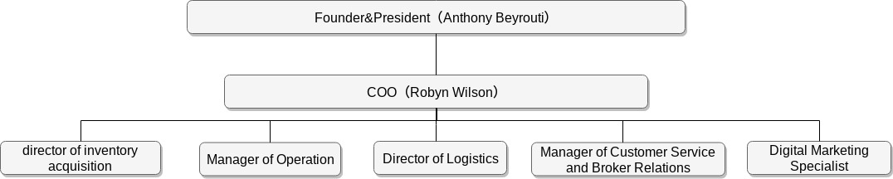

**Corporate Culture:**

Venue Kings pride themselves on being able to provide fans with tickets enabling them to attend their favourite games, events, concerts, and live performances. Analyzing Venue King’s advertisement banner, If any indication, it looks like the team at Venue Kings is formed of diversity and employees that are trained and ready to help with any of your needs! (VenueKings, 2018).

**Training Employees:**

Venue Kings should be training employees that deal with customer service inquiries and issues. Employees should be patient, polite, knowledgeable and friendly when handling customer calls and support tickets. (*personal communication,* March 2018*).*

On the Venue Kings website “About Page” they claim that they strive for outstanding customer support and with a 100% buyers guaranteed. (VenueKings, 2018).

I would assume that because of this, support agents would be able to have the power to make the best decision on customer ticket refund issues! Hands on training is also done with the employees getting a feel of the computers and how the ticketing system works.

**Compensation**:

In terms of compensation we were not able to find anything related to Venuekings. So to compensate for this we have looked at a similar company, Ticketmaster. Looking at ticketmaster, they have been very generous to their employees. They provides a wide variety of plans such as health insurance/pet insurance and a 401k plan (*Ticketmaster Benefits Review. (2018)*. They also give their employees two free tickets every year. These compensations are only given to those who are full time salary employees (*Ticketmaster Benefits Review. (2018).*

**Incentives**:

Venuekings offer a number of incentives to its customers and employees. For the customer they offer a wide variety of sporting events, Concerts, Theater, and other. They also offer 10% reward on every purchase as a promotion to attract new customers (Venuekings (2018). The company also promotes a email Subscriptions to let customer follow up on future events. As for the employees, those who work in sales are rewarded with air miles if they reach a certain amount of sales per year (*personal communication,* March 2018*). Nb*

**Recommendation**:

After reviewing Venuekings, we have come up with the conclusion that they have been able to hold up only part of their mission statement. In terms of delivering the highest customer serves, they are one of the top companies in their industry. However, they do not fulfill their promise of being leaders in the broker industry. The main reason for this is that they are not very well known. We have shown this in the our SWOT analysis as one of their weakness.To help them strengthen their image we recommend that they start to focus on an aggressive marketing plan. We advise focusing on social media, do to a huge portion of their future and present target market currently using it. Then gradually work with your partners at San Jose Sharks, Seattle Sounders, and Vancouver Whitecaps to get the name out there. For example having their logo on their partners websites. If this change is made we strongly believe that Venuekings can become a dominant force in the industry and fulfill its mission statement.

**References:**

R. Botteselle, personal communication, March 2018.

*Ticketmaster Benefit Review.* (2018). *Retrieved from*

<https://www.glassdoor.ca/Benefits/Ticketmaster-US-Benefits-EI_IE8873.0,12_IL.13,15_IN1.htm?countryRedirect=true>

*VenueKings*.(n.d.).Retrieved from

<https://www.linkedin.com/company/venue-kings/?originalSubdomain=ca>

Venue Kings. (2018, April 3). *About us*. Retrieved from

<https://venuekings.com/aboutus/>

Venue Kings. (2018, April 3). *Buyer Guarantee*. Retrieved from

<https://venuekings.com/buyerguarantee/>

Statistics Canada (2016, October 7). *Online Shopping.* Retrieved from

<https://www.statcan.gc.ca/pub/11-402-x/2012000/chap/retail-detail/retail-detail01-eng.htm>

Management: Retrieved from

<https://www.linkedin.com/company/venue-kings/>

Venue Kings. (2018, April 3). *About Us*. Retrieved from Venue Kings: <https://venuekings.com/aboutus/>

R. Botteselle, personal communication, March 2018.