**FitHub** 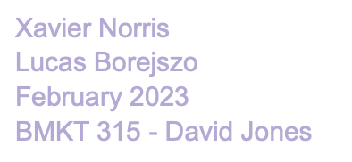

**Business Overview**

FitHub will redefine the way you search for, rent and rent out fitness equipment, in British Columbia, and further across the country. We will work to be an avenue for people to not only find and rent fitness equipment, but also rent out fitness equipment you may use less. This will put old dusty boards, etc. to use, while also putting some cash in your pocket.

We will be a partnership with an equal share, drive and goals with where we want our business to go.

**Marketing Plan**

FitHubs main goal is to connect active people who own fitness gear with active people who don’t own fitness gear. I know from experience there are people who have paddle boards, kayaks, mountain climbing equipment, etc. that they only use a handful of times a year. FitHub gives people the chance to put those items and equipment to use. If you want to use a paddle board you have the option to buy one, or rent one at whatever beach/lake you may be at. FitHub gives you the opportunity to potentially rent out an inflatable board that you can take anywhere you’d like. Not every body of water has rentals available so this is just one example of how FitHub can be a better alternative to renting from generic shops or buying. Not only this, but you are also putting money in the hands of the people and not bigger businesses.

FitHub will be promoted through different hubs across social media and through partnerships with the City of North Vancouver, primarily. We have built a rather extensive connection with the community and would have a decent base to market through. We will push the idea of making some extra cash, people are so money hungry nowadays, just a little extra cash for basically no effort will be a huge incentive for people to want to put their equipment for rent. We have several different avenues to market our business including newsletters in neighborhoods,

schools and communities we are connected to, a website and solid online presence, as well as all social media outlets such as Instagram, Facebook and Linkedin.

**Operations Plan**

FitHub HQ will be located in Mr. Norris newly refurbished penthouse basement suite. There are two main objectives when building this business. The first simply building a functional website and app, each with a good UI and smooth functionality. Secondly, finding a customer base not just interested in renting equipment for their own use, but also renting out their own equipment. Of course, we have access to high speed internet. Once off the ground, we will move to a more professional setting, like an office space to further our business.

**Financial Plan**

The beauty of the FitHub business venture is that once initial costs are complete, running the business will cost almost nothing. With a website and app developed, most money will go towards marketing and maintaining the app and website. Of course, commitment from customers is low outside of the damage deposit and rental fees. We expect to reach at least 0.5% of all Vancouverites and hope each one of them spends 50$ throughout year one. We believe this is a fair number and would put us in just a small deficit after year 1, which can be expected for a new business. 