

And

https://1drv.ms/p/s!AlHIcwJmcQSshUZ-iSH2XMXLBV3u?e=L5g404



# 

Liam Gottschalk

Creative Director

2055 Purcell Wav. North Vancouver. BC V7J 3H5

March 30, 2022

TruEarth

1234 Granville St.

Vancouver, BC, V67 8F7

RE: Business Proposal Letter

Dear Truearth team,

Vaxal Marketing has risen to prominence in recent years and is currently one of

Vancouver’s top ten advertising businesses. The Vaxal firm has helped

numerous small enterprises in Vancouver in recent years and has climbed to

remarkable heights, which we consider to be our greatest achievement to date.

We are aware that TruEarth has expressed interest in working with our firm to

assist them to develop a stronger marketing plan for their product, which is why

we’re submitting this proposal.

Vaxal Marketing is searching for new methods to expand and grow. Our teams

are paid on a commission basis. Our charges for planning, producing, and

implementing your marketing vision will be covered by 15% of your marketing

Budget.

If you have any further questions or inquiries, feel free to email me at

vaxalmarketing@gmail.com or phone me directly at (604)-345-9876.

Sincerely,

Armaanjot Kaur

# 

# 

# Executive Summary

# Table of Contents

**Executive Summary** **2**

**Table of Contents** **3**

**Corporate Overview:** **4**

Accomplishments/Accolades 4

**Client Situation:** **5**

**Objectives of Campaign:** **6**

**Target Market Profile:** **7**

**Media Plan:** **11**

Radio Campaign: 11

Chart A 11

Chart B 12

Out of Home (OOH) 12

Digital 14

KPIs 15

Television 17

**Appendices** **20**

1 20

2 22

3 23

4 25

**Bibliography** **26**

# 

# Corporate Overview:

We are VAXAL Marketing, a Vancouver based marketing company serving the Greater Vancouver Area. Our team consists of Vivian Jones who heads our Strategy Division, Xavier Norris head of Marketing Engineering, Adam Bayloun head of Production, Armaanjot Kaur head of Finance, and Liam Gottschalk head of Creative. We are a new, young and motivated marketing company. We pride ourselves on our fresh outlooks on the marketing industry as well as our intuitive understanding of modern marketing strategies. Our focus day to day is both to make Marketing understandable and intuitive for our clients as well as promoting creative and out of the box ideas to really grab the attention of our clients’ markets. Some of our best clientele include companies from the Greater Vancouver area such as: Solegear, Enwave, Saltworks, Ostara, Nexii, Corvus and Hydra. The companies who prefer our agency all are attempting to bring cleaner, greener business practices to our home of Vancouver. While not a requirement, our history as an agency is very much intertwined with working with companies who place a greater than normal focus on the environment and sustainability.

Our Teams work on a commission basis. Fifteen percent of your Marketing budget will cover our expenses for planning, creating, and implementing your marketing vision.

Our offices are open during normal business hours. Any questions or concerns our clients might have can always be answered by getting in touch with our HQ during normal business hours. Outside of those hours your personal Marketing agent, who is directing your campaign, will be more than happy to answer any questions by email, text or call. It’s extremely important to us that you are both aware of when your advertisements are running as well as the engagement they are receiving. We keep you informed and updated every step of the way, with email updates on viewership metrics as well as reminders of where and when your upcoming adverts will be running.

## Achievements/Accolades

* 2020: Ranked on the Growth 500.
* 2020: Top 10 School Web Design Firm.
* 2020: CEA Sustainability Award
* 2021: Outstanding Commitment to Employment Equity Award.
* 2021: Silver place winners of the Canada Post Integrated Marketing Award.

### 

# Client Situation:

TruEarth is a successful company, with many opportunities. The company is still in its growth stage. It has many goals to donate along with goals of reducing more and more landfill from waste every year. More and more people are starting to make eco-friendly choices, meaning that the market size is growing every day. The company has a plan to eventually move from laundry strips to other types of cleaning products.

The company started working with AIM (All Inclusive Marketing) roughly a year ago. The agency expanded on the company’s social media presence across: Facebook, Instagram, Twitter, Youtube and Linkedin. On Instagram, every ad receives roughly 1500 views. The company receives a lot of consumer feedback and support from an interactive instagram tag, #truearthmovement. The company uses a lot of search engine advertising, content marketing, email marketing and many other digital platforms that appear to have had a positive impact. Video campaigns were also heavily utilized, using a mascot of sorts. The mascot is a 30-40 year old woman with dyed blonde hair in a bob. She wears a red shirt and blue jeans for a very casual ‘mom’ look. The ads are very informational and typically long, usually with a fun approach. There are plenty of video advertisements already in motion, which is great for raising brand awareness.

TruEarth’s product is the most environmentally friendly laundry detergent in the market. The brand has many loyal customers. The product is marketed internationally however most sales are derived from Canada and the US. The company needs more brand awareness. Many people are unaware of how much of an impact this company can make, let alone that it exists. Raising awareness about the brand would likely draw more environmentally conscious consumers.

Many companies suffered from the economic crisis due to the global pandemic, however TruEarth continued to grow. The company even managed to donate 5 million laundry loads to families since the start of the pandemic. The company’s social and environmental impact makes people feel good about purchasing their products. Now that the market is starting to recover from the pandemic, there is a large opportunity to grow the company further.

Tru Earth typically sells products through online channels, directly and through a few other retailers. The company is already working with Instacart, Amazon, and a few other small retailers. The majority of sales are online, along with the majority of advertisements. Tru Earth’s well made instagram presence works well with instacart and the paid social media ads on the platform.

The company is in a very good place, however, there are a few threats that should be addressed. The product has a higher price than many cheap alternatives. The economic crisis led people to change their behavior and make cheaper purchasing decisions. The company’s main weakness is that many potential customers are unaware that they have this option. Current marketing campaigns need to be expanded on.

The laundry detergent industry is an oligopoly. It is very difficult for new companies to compete in this marketplace, however Tru Earth has an advantage. Eco-strips are a disruptive product. With liquid detergent, new companies would have to convince the public that their detergent is better. This is difficult to do because everyone is typically very loyal to their laundry detergent brand. Eco-strips are innovative. Tru Earth has a massive marketing opportunity to deter people from liquid detergent all together. The company’s 4 largest competitors are: Procter & Gamble (P&G), Henkel, Amway, and Church & Dwight. The two largest competitors in the industry are P&G and Henkel. P&G has 55% market share in the laundry detergent industry while Henkel possesses 35%. These brands have many similarities. The price is similar ($66 for a 2.72 L jug), the product is similar, and the target is similar.

For further information, see appendix 3.

# Objectives of Campaign:

Tru Earth had an impressive three year growth of approximately 846% over the course of the pandemic, growing from just a handful of employees to over 200. With such a tremendous increase in growth already, the goal of our campaign is to further what the brand has already been very successful with. We will do this by increasing revenue (ROI) and expanding the brand awareness to a wider audience. We will do this at a very important point of time when the pandemic is coming to a close.

The current total market share of Tru Earth’s revenue currently occupies 2.1% of the laundry segment in Canada. This works out to be just over $41 million CAD out of the $1.915 billion CAD total revenue in the Canadian Market. Our objectives are to have the brand conquer at least 3% of total market share by the end of one business quarter for our campaign and expose brand awareness to the fullest.

***Our objectives can be laid out coherently using the S.M.A.R.T framework:***

* **Specific:**  Increasing brand awareness and total revenue.
* **Measurable:** Reaching 3% market share total in the Canadian laundry care segment which works out to be almost $57.5 million CAD.
* **Actionable:** Acquiring 0.5% of an increase in revenue through the quarter.
* **Relevant:** Attaining 1:5 ROI on the budget we were given to foster a solid foundation in the marketing industry.
* **Time-Bound:** Acquiring a 0.5% revenue increase throughout the quarter while targeting a total market share of 3% by the end of the quarter.

# Target Market Profile:

Gen Z’s, although the most eco-conscious age group, should not be a focus in our target market. This demographic is, for the most part, too young. These people are in elementary school, high school, or university and we do not believe that they have the purchasing power to want to spend more for their laundry detergent if they're even buying their own to begin with.

When it comes to picking an age group for our demographic, through our extensive research it is clear we want to be targeting millennials. 75% of millennials are willing to spend more money on eco-conscious products, compared to 64% in gen X and 57% in baby boomers. Millennials also have much more desire to change their lifestyle when it comes to their own health, as well making more effort to become environmentally friendly. We believe that these qualities and life choices are very important when looking at our target market because they relate heavily to the goal of your product which is to have clean clothes while being environmentally friendly.

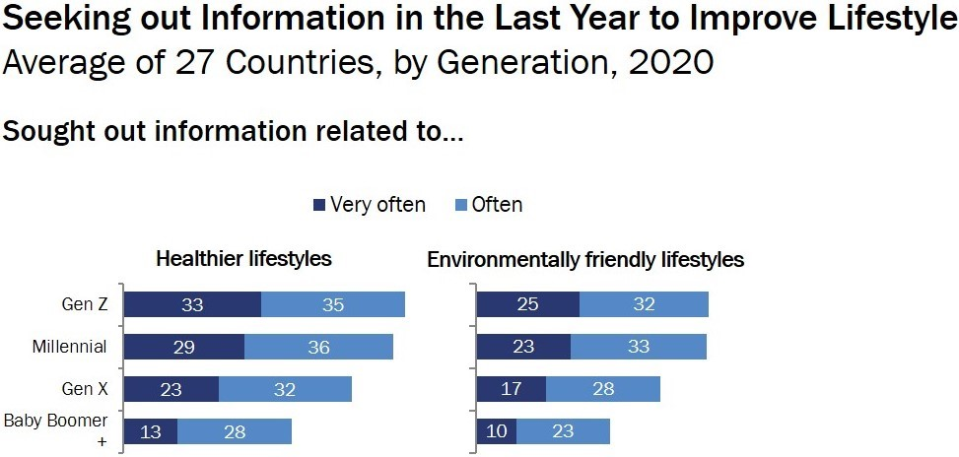

Out of our millennial target group, 2 main groups of people pop out; we believe these people are most important when it comes to creating our ads. First, we have your younger family of consciously aware parents that have careers and are environmentally aware. They are anywhere from 26-42 years of age. They are usually very happy people, who live wholistic lifestyles. They appreciate time with their family and friends. They live in the city but enjoy getting into nature on the weekends or whenever they can, for daily hikes or even weekend camping trips.

Statistically, women are more likely to be the ones doing the laundry in the household. They are located in the city center or on the outskirts in the immediate suburbs. These cities are full of young vibrant places that are very happening, full of activities and events millennials would enjoy. Popular examples are Quebec City, Ottawa, and Vancouver.

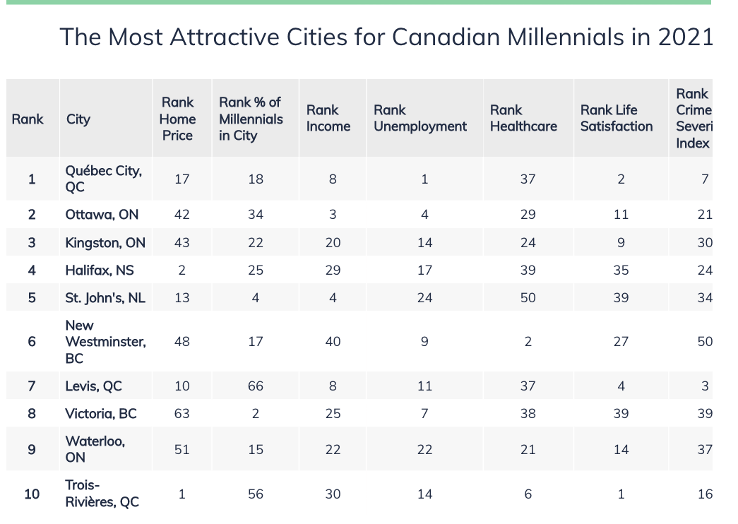

These people have undergraduate degrees and are well educated. A study from the University of Essex shows that people with post-secondary education are 25% more likely to be environmentally friendly than those with no education. Thankfully for us, In 2016, more than 54% of Canadian millennials had attained their undergraduate degree. They enjoy going for hikes and generally being outdoors. Strive to be healthy and clean in their lifestyle. Another benefit about picking millennials as our target market is how brand loyal they have proven to be. Over 50% of millennials claim they are extremely brand loyal. This is the generation of technology, these people are constantly on their devices; they use many forms of social media, most commonly facebook, instagram, and twitter. They are watching things such as youtube or tik tok, for entertainment or educational purposes. They are also still, for the most part, using cable generally for their news and to watch sports broadcasts that are not yet streamable. Speaking of streaming services, millennials have the highest amount of ongoing subscriptions for all streaming channels. Although a market we feel we can easily target, some challenges include: a limited budget due to having a child, not making a ton of money since they are early into their careers, and also that they may not have a washing machine. Millennials nowadays are showN to be worse off than prior generations, average net worth is on average 8000$ less than prior generations.

The second group of people would be single young adults, male or female, in the same age group. We have chosen to focus more on the families more for a few key reasons. First, we know that most families in Canada live on their own. They are no longer reliant on their parents and that makes it certain that they will be taking care of their own chores- such as their laundry. We also know that when targeting a family to an individual, this is naturally targeting more people, therefore more laundry totaling in more product. We felt as this target was important to mention as we can have them in the back of our minds while creating our media plan for the main target.

Day in the life for this target would be waking up early -around 7 am- to get ready for work, making breakfast for themselves and their children as well as driving their children to school from 7:30-9:00. Once they are at work they may be listening to radios or podcasts while working and are definitely periodically checking their social media. At lunch time they are definitely checking their phone, connecting with friends as family as well as reading news and staying up to date with global occurrences, they may also be using the time to talk and connect with coworkers, possible gossiping about their boss.. After work -around 5 pm- they are driving home through rush hour, listening to radio, music, or podcasts. They pick up their child and drive them to their activities. These families are going to the grocery and running errands at least once a week, most likely on weekends when they have a little more free time. Once they're home from work and their kid's daily activities, at around 6 pm, they are cooking dinner for their family and not long after putting their kids to sleep. Once they put their children to sleep they are winding down for the day. This likely includes watching tv shows, scrolling through their phone, playing video games or recreational board game, sex, and reading books.

The best time to reach these people would most likely be in the evenings. Definitely at a time after work/school when they are on their phones, driving around the city or taking public transit, as well as doing activities they enjoy after their workday. This time could be anywhere from 4-10 PM. Ads could also be considered around lunchtime when people are on their breaks and on their phones.

# Media Plan:

Overall, The main objective of the campaign is to raise Tru Earth’s revenue by 5% and increase its market share by 29%. Vaxal intends to reach this objective over the next quarter using personally selected strategies and tactics in the following subsections that will derive the best possible response from Tru Earth’s target market.

## Radio Campaign:

Radio campaigns are good for raising brand awareness and having a strong impact on the recipient. There is a notable increase of people playing music off of their phones, however there is still a large enough number of listeners on the radio to reach to make a very beneficial impact for your company. News channels are still used very frequently by your target. While driving, the target usually wants to check on traffic. Additionally, young children usually enjoy flipping through the channels on FM stations. Proper targeting has the potential to reach a large number of your target.

People are strictly listening to radio advertisements; the message has a larger impact and higher retention than in video advertisements. There are 2 messages that Vaxal wants to pursue. One has a Focus on the environmental benefit of your product, the other focuses on the clean and simple elements. The environmental focus should be emotional, as the wellbeing of the environment is a major concern of many people. The goal is to make people feel good about purchasing your product. The clean and simple message should mainly be educational, relaying the ease and effectiveness of eco-strips. This should urge curiosity from your target market, and make them feel compelled to try eco-strips. It would be wize to make use of a slogan and jingle of sorts to play at the end of every advertisement. This will make the ads memorable to recipients. Vaxal believes that “be greener, be cleaner” is a great slogan because it is easy to understand and rather catchy. We have drafted 2 creatives for radio advertisements. To look more in depth, see appendix 4.

Tru Earth’s target market is full of young parents, mostly working a 9-5. At this stage, young parents spend plenty of time driving around. Work travel, groceries, pick-ups and drop-offs, are only a few of the things that the target consistently does in their vehicle. The following chart represents when the target market is in their vehicle and what they might be doing. Chart A represents the working parent. Chart B represents the stay-at-home parent.

#### Chart A

|  |  |  |  |  |
| --- | --- | --- | --- | --- |
| 7:30am-8:30am | 8:30am-9:00am | 9:00am-5:00pm | 5:00pm-6:00pm | 6:00 - 9:00 |
| Dropping off kids at school | Driving to work | Target is working, typically not driving | driving home after work | Recreational activities  Social activities |

#### Chart B

|  |  |  |  |
| --- | --- | --- | --- |
| 7:00am-9:00am | 9:00am-3:00pm | 3:00pm-3:30pm | 3:30pm-9:00pm |
| Time spent at home, not typically driving | Errands, social/recreational activities, gym | Picking up kids from school | Picking up and dropping off kids from recreational/social activities |

When we know that kids are in the car (7:30am-8:30am and 3:00pm-3:30pm), chances are that the radio is playing music on popular FM channels such as: The Beat (94.5), Kiss Radio (104.9) or Jack FM (96.9) Stingray (95.3). When parents are driving by themselves, they are more likely to listen to the news, as well as traffic information. At peak times when we know parents are driving alone (8:30am-9:00am, 9:00am-3:00pm, 5:00pm-6:00pm) it will be effective to have a targeted ad frequency on AM platforms such as: CHMJ (730) and CKWX (1130). During times when we are uncertain of who is in the vehicle and what they may be listening to (3:30pm-9:00pm), there should be a 30/70 focus between AM and FM.

The cost of radio advertising varies depending on frequency and the demand of the selected channels. The channels that Vaxal recommends for Tru Earth are rather costly, however specific targeting can allow Vaxal to get the largest ROI from the platform as possible.

We expect that daily impressions will total 210 listeners a day, this expected total also means that our expected CPM will amount to $2.05.

## Out of Home (OOH)

OOH tactics are cost-effective ways to reach a large audience. Targeting is very difficult, however not impossible. OOH is also very difficult to measure, as it’s impossible to record the number of people viewing it. The most commercial areas in Greater Vancouver that Vaxal intends to utilize include: Robson street, Granville street, Commercial drive, Downtown Vancouver (between Hastings, Georgia, Howe and Burrard st.), Gastown, and South Main st.

Vaxal plans to use a large variety of tools extensively to raise as much brand awareness in the targeted areas as possible. The agency believes that the most effective tools include: transit shelters, electronic LED signs, interior cars, 70s, superboards, posters (backlit, station), billboards and pillar ads. Banners in skate rinks used for recreational activities will be viewed largely by your target market, as parents usually spend over an hour in these places.

These cost efficient platforms will work well with digital platforms. OOH will reach a large audience of people, however it will not bring Tru Earth many sales on its own. Many of these advertisements will make your target consider your product. Educating the public about your eco-strips is very important from a marketing perspective, as it will tie into acquiring more sales down the road. Digital platforms will lead consumers to your website, however your company needs a larger base to market to. OOH will work closely with digital tactics to inform people of the brand and then later use point-of-purchase to seal the deal. Each will work sequentially to do a brilliant job of reaching the media campaign’s objectives. OOH will be perfect for reaching a large number of people in the Greater Vancouver area.

Of the selected platforms, Vaxal wants to focus heavily on transit shelters and billboards. Transit shelters will reach a large part of the company’s target when they have time to ponder over things such as laundry detergent. Billboards are another useful way to reach a large audience of people. The objective of these billboards is to catch people’s attention. The more simple the design, the better. The point of this platform is to deliver a very clear message, with little decoding necessary for the recipient. Vaxal is leaning toward a new slogan for the company, “Be Cleaner, Be Greener”. The advertisements will also include branding through the company logo and the colors of your packaging. A ‘learn more’ note will also be next to a QR code, allowing easy access for more information. This is an opportunity to further educate the public in Greater Vancouver about your eco-strips. These ads could potentially spark a conversation between consumers and lead to word-of-mouth marketing due to their creative design. The creative appeal of these ads will also make them recognizable. Overall, this part of the campaign will educate people living in Greater Vancouver about your product and make them at least consider changing their purchasing habits.

OOH will be essential for raising awareness about the brand, however it will not yield a large consumer acquisition. OOH will work closely with digital tactics to inform people of the brand and then later use point-of-purchase to seal the deal. Each will work sequentially to do a brilliant job of reaching the media campaign’s objectives.

OOH advertising will play a large role in this campaign. $175,000 of the given budget will be allocated to OOH alone. Transit will be very beneficial, therefore Vaxal has decided to spend $75,000 on the platform. This goes beyond shelters to 70s, interiors, and other transit advertisements. The remaining $100,000 will be spent on billboards, posters, and other similar advertisements. Roughly 698,990 people will be occupying the previously mentioned areas on a daily basis, and 235,985 will be taking public transit. With this in mind, transit advertisements will yield a 3.45 CPM and billboards will yield 1.56. Transit advertisements will be more costly, however due to the placement they will attract the most customers to the website.

## Digital

Digital tactics are not favorable for gaining awareness, however they are perfect for reaching out to a specific target. These tactics will be key in acquiring consumers and driving people to the truearth website. The most effective digital platforms for Tru Earth to use include: search engine marketing,banner ads and paid social.

The global pandemic changed the behavior of many consumers. Many started working from home, and almost everybody has switched to a more digital lifestyle. More products are being ordered online and more people are spending time on their phones and computers. Tru Earth’s main source of sales is derived from the company itself, through online purchases. It would be beneficial for Tru Earth to supply products in local retailers for ease of access, however the digital approach is also effective. Taking this digital approach, it’s important to have extensive digital marketing tactics alongside. Due to the ease of targeting in digital campaigns, Vaxal has an opportunity to achieve a large response and high acquisition from Tru Earth’s target market.

Social media is a large advertising platform that is heavily utilized by Tru earth’s target. The platforms that reach the largest number of the target include: Facebook, Instagram, Youtube, and Twitter. These media platforms are important to take advantage of as they are cheap and have a large reach.

The placement of these advertisements is important. The target tends to use digital for work, online shopping, activity planning, social media and news updates. Ideally, the perfect time to attract consumers is while they are already making online orders. Including digital banners for popular online retailers such as Amazon and Walmart will be very effective. Another key platform would be popular online news reports such as: CBC, CTV, and Global News. Rec center websites and airline websites are also efficient. As the pandemic is slowly ending, parents are signing their kids up for activities. Additionally, there is about to be a large push of people wanting to travel now that it is deemed more safe. Each of these channels will effectively reach young parents and other potential buyers.

### 

## KPIs

Most digital platforms will provide a report of the campaign’s CPC, CPM and CPR, allowing us to see the number of impressions and measure its effectiveness. The cost of marketing through many of the chosen platforms will be on a PPC system. While this is true, we can assume that each selected keyword for search engine marketing will attain roughly 100 views daily with a CPC of $2.32 on the search network and $0.58 on the display network. Each keyword will yield roughly 600 impressions daily. Tru earth will likely yield a click through rate (CTR) of 1.5% through Google Ads.

Social media platforms have a similar platform. Facebook ads will each receive around 3,000 impressions each, with a CPC of $1.72 and a CPM of $11.45. This platform is the costliest, however it will reach the largest amount of Tru Earth’s target market. Instagram is a much cheaper platform with a CPC of $0.72 and a CPM of $3.00. Each ad on Instagram will receive an average of 1,500 impressions.

The first media platform we would like to use for our creative video is Meta. Meta is the company that currently maintains ownership of Facebook, which is still to this day the most commonly used social media among millennials, our target market, as well as Instagram, the third most commonly used social media among millennials. Meta is also the platform with the most businesses already using them as a media option for their campaigns, as they have over 140 million business customers around the world. We like Meta because they have so much data on their database that it makes it easy for us as marketers to create very targeted ad campaigns directly to our target market. This includes location, demographic, hobbies and even interactions. Meta ads work by bid system, meaning that we will set a maximum budget per day and meta will choose whether or not our ad is the one that gets chosen, based on the target market we give them, the relevance of our ad, and the quality. Therefore we will allocate a certain amount of money that will be spent overtime. We think that Meta will give us the most awareness out of all our digital ads. Therefore we have decided to allocate 48% of our digital budget which comes out to 36,000$. Based on research and our industry knowledge, we predict that in the laundry detergent industry, there will be on average a 10$ cpm. Now, that may seem high but in reality a high bid like this will assure that your business gets prime time ads. Also, our bid will be made cheaper if there are no contending bids that are near our dollar amount, lowering costs even further. We will aim for upwards to 40,000 impressions per day, meaning our CPM will cost 400$ per day, we estimate around 1.5% of those impressions will interact with the ad per day. If our target is a 1:5 ROI, that would mean we would need a conversion rate of 0.5%. Not only do we think this is easily achievable. We also believe that our cpm’s will come out cheaper than 400$ a day, which means reaching even more people with our current budget.

Next we want to look at banner ads. We are going to use banner ads as they are a cheap way of gaining awareness with our target market. These ads are much cheaper than the meta ads as well as the search ads. We also feel as though they are the least important of the three digital sectors so we will allocate the least amount of money to that from our budget which will be 10,000$. Google uses a very similar bidding system to meta, but we know these banner ads will be cheaper since they don't get the same amount of attention from the consumer as a video on your feed or a search ad in your browser. Therefore, we will have a maximum bid of 3.50$, just above average to, again, make sure we hit those prime time slots. With this budget, in a time frame of 3 months, this would allow us to spend 111.11$ a day, equating to upwards of 32,000 impressions per day. Calculating ROI on banner ads is a little trickier, but we are confident in getting a 1:5 ROI as previously.

Lastly we will be using google search ads with a budget of 56,000$. We think search ads are very important as they are a good point of acquisition, and the last attributed part of the campaign. These are more competitive with pricing as they are highly competitive throughout the industry. For the search ads, we will put in at costs per clics (CPC) instead of impressions (CMP) as we feel the clics are a most important metric for our calculation, as well as telling us whether the whole ad campaign has been working. We are gonna put in a maximum bid at 3$ CPC. For these search ads we must select a few key words, each of these words will have their own CPC, and we must decide what our budget is for each word. Below are the words we will use with our bid amount:

“**LAUNDRY DETERGENT**”- 2.50$

“**DETERGENT**”- 2.50$

“**LAUNDRY**”-2.00

“**ECO STRIPS**”-2.00$

“**ECO FRIENDLY DETERGENT**”-2.00$

These will be our 5 key words. For these keywords we will use a broad match, meaning if there are any of these keywords in a search, our ad will appear if google decides we have won the bid. These keywords average out to 2.20$ CPC. With a budget of 56,000$ we have a budget of 622.22$ daily, through our three month campaign. This would allow for ~282 clics a day. If we were to meet our goal of 5:1 ROI, we would need around a 55% conversion rate per click, this may be a little high but we know that this is the last point of contact the consumer is looking to make a purchase and tru earth will be one of the first things they see.

## Television

Tru Earth has already entered the market of video ads in their own original form by instead of posting short 15 second ads that one would normally skip before proceeding on to what they were originally planning on watching, they produce on average, 2-3 minute skits that focus on creative videos people would actually go out of their way to watch rather than ad they are forced to watch. Since Tru Earth has already entered the Youtube Market with their own niche, we plan on expanding their TV beyond just Internet Ads more towards News Broadcasting stations to branch out to adults 25 to 54 who spend on average every week, 20.3 hours viewing TV. TV is the overall media leader in producing an impact on impressions, performance of online advertising, and delivering the most impactful return on investment of all media. TV reaches 93% of Canadians per week, with a staggering 88% of that audience being our target group, Millennials. Untapped by the company, it holds huge potential on marketing ROI.

Preferrably creating a 30 second - 45 second ad, contrasting the ingredients, post-clean factor and ease of use with standard industry detergent heavily swaying peoples’ thoughts on going for just the “cheaper option”. Setting aside $5,000 for a well produced ad, that would catch peoples’ interest and keep them hooked like how Old Spice rejuvenated their marketing presence with their famous one take ads. With a total of $125,000 set aside for TV related expenditures, equipping the production crew with a studio & camera rental, props (if needed) and other miniature related costs for $5,000 is very manageable. The outline for production of the ad goes as follows:

1. Prioritizing on making the first few seconds of the ad explosive as possible, to keep the audience engaged, addressing them with common problem such as the toxicity and wastefulness of regular detergents or inferring a first world problem such as normal detergent being too heavy to drag to the building laundry room or local laundromat.
2. Highlight Tru Earth’s key aspects such as eco-friendliness and ease of use.
3. Timing the ad to be as short as possible while jam packing all noteworthy information in.
4. Pose the audience with an incentive towards purchasing eco-strips from the brand.
5. End the ad with a specific call to action such as redirecting users towards the website to be greeted by a subscription email notice followed by reward of a discount coupon.

With $5,000 dollars being set towards production costs , we still have $145,000 to play with. For our first venture, we are going to be using CBC Local News, 5pm and 10pm slots, with the 5pm slot costing $455 and the 10pm costing $220, we plan to run each ad with 8 occupancies per month respectively, with an approximate combined CPM of $10 and CPP of $210, running each slot for 52 weeks with a 10% discount, the 5pm slot comes out to $39,312 after discount, while the 10pm slot comes $19,008 which both totals up to 58, 320. If we're looking at similar ad rates for other stations, we’ll use the same time slots and allocate those costs for CTV Vancouver which will have around the same viewership and that will take the overall costs up to $125,000.

Having two local news stations air our ad total of 4 times a day will boost our reach in Vancouver heavily. CTV’s digital audience has had significant growth of of over 230% since 2018 averaging about 800,000 viewers per month, advertising with them will help us grow to be a staple in the Vancouver laundry care industry, which is what we want, so that Tru Earth’s home city, Vancouver, can do the most sales compared to any other.

# Appendices

## **1**

Creative: (Drafts)

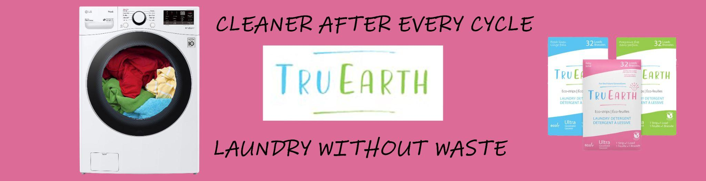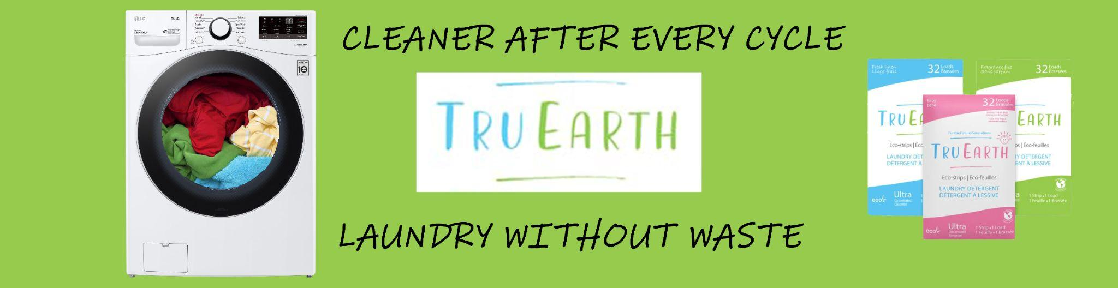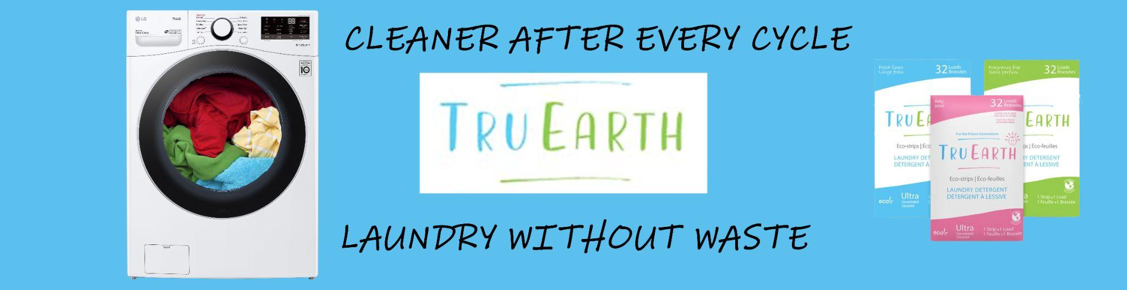





## **2**

80% Water Stat Advertisement Script

Scene: Busy day in a grocery store laundry detergent aisle.

Customer: looks at popular liquid laundry detergents, then picks up Tide.

Mascot: Appears and stops Customer from grabbing it.

Mascot: (Whispers like it’s a secret) “Psst. Are you really about to spend $53 on water?”

Mascots: Grabs see through laundry detergent container from out of shot, representing 80% and 20% of a liquid laundry detergent.

Mascot: “80% of every liquid laundry detergent is just water. That means that you are about to pay full price for only a fraction of the cleaning power you need to get a fresh clean load!”

Mascot: Displays Tru Earth product on the palm of their hand with a shining effect behind it to accentuate the product.

Mascot: “Tru Earth Eco-strips are compact, lightweight, simple to use alternative with absolutely zero waste! Get what you’re paying for, with free shipping and 100% money back on your first order.”

Customer: “Wow! But I have three boys! There’s no way a strip can get the cleaning power I need!”

Mascot: “We have you covered!”

Scene: Shifts with a spinning effect to an average household laundry room. White walls, tile floor, and a window showing two boys wrestling outside.

“Mascot: “Tru earth eco-strips are designed to cut through the gnarliest dirt and stench. Just throw in one strip for a perfectly clean and sweet smelling load every time. -throws a strip into very dirty laundry load then opens it to show clean laundry, Mascot picks up a blue (packaging color) shirt and takes a deep breath, smiling-”

Scene: Two boys run inside, covered in dirt and mud.

Mascot: picks up tru earth package and sighs.

Mascot: “Good thing Tru Earth has me covered.”

Scene: Tru Earth package appears in front of a now blurred scene along with the website link.

## **3**

Environmental Scan - Tru Earth

Economic:

The laundry detergent industry is very large, currently just over $120 billion USD. Tru Earth makes up over $30 million CAD of that total, equivalent to 2.1% market share. The Canadian industry for laundry detergent was around $1,523 million USD in 2022. This is much smaller than the industry in the US, which is $14,959 million USD.

Another notable occurrence is the current inflation in Canada. The consumer price index (CPI) has grown rapidly throughout the start of 2022. In January, the CPI rose by 0.9%. In February, the CPI rose by 1%, being the largest increase since 2013. The direct effect on the laundry detergent industry is that people are now willing to spend 9.1% more on laundry detergent.

Regulatory:

There are little to no notable regulations for Tru Earth aside from the usual ones: Competition Act, Advertising Standard Bureau, etc. Transportation of the product is not an issue throughout Canada or the US. Your product is low-risk and it doesn’t include a choking habit or possible toxin like other liquid detergents.

Demographic:

The Canadian market size is relatively small compared to other regions. The focus of this campaign is in Greater Vancouver, however your company would really thrive if it focused more in the US. Many sales are already derived from the US, so a higher frequency of advertisements would enlarge your market. Two other regions with high laundry detergent consumption rates to focus on in the future are Europe and Asia Pacific.

Everyone uses laundry detergent, however eco-strips have a more specific target. The user usually makes a higher than average income. Additionally, they are usually new families. One parent typically stays home with the kids while the other goes to work. With these factors in mind, we can figure out that we should be advertising to the wealthy, heavily populated and commercial areas. These areas include: Robson street, Granville street, Commercial drive, Downtown Vancouver (between Hastings, Georgia, Howe and Burrard st.), Gastown, and South Main st.

Environmental:

As most of the world is getting over the global pandemic, many people are changing their behaviors. During the pandemic, many people switched to buying products online instead of from stores. This provides a large opportunity for the use of digital advertising.

Of course, the biggest environmental factor to consider is the rapidly declining environment. Many people are urged to reduce their carbon footprint. These people feel saddened by the state of the environment and they feel good about making eco-friendly choices. We want your target to feel good when they buy your product so that they are urged to buy it again.

Sociocultural:

Your target focus for this campaign consists of millennials who have an urge to make cleaner/healthier decisions. Typically, this group is well educated, usually having an undergraduate degree. They enjoy outdoor activities: camping, hiking, kayaking, skiing, etc. The target spends quite a lot of time on social media, mainly: Facebook, Twitter, Youtube and Instagram. As far as recreational activities, the target usually spends time in the gym, yoga classes, and catching up with friends through grabbing coffee, brunch, dinner, or alcoholic beverages. Errands also take up a large portion of their time. Groceries, driving kids around and buying utilities are the most common errands.

This target is also very loyal to certain brands. Tru Earth’s customer base is extremely loyal, meaning that there is a higher chance to keep customers for longer periods of time. A possible threat to consider is that new families are usually on a tight budget. They are early into their careers, recently having purchased property and supporting children. It is important to target families that can afford the product.

Competitive:

The industry for laundry detergent is massive. Tru Earth currently has a small portion of the market, however it has the potential to gain much more. Your company has 2 types of competition, direct competition and oligopoly. There are other small companies that provide eco-strips, however none of them are doing close to as well as Tru Earth.

Liquid laundry detergents are still the most popular purchasing decision for many people. The industry giants that Tru Earth faces include: Procter & Gamble, Unilever, Church & Dwight Co., The Clorox Company, P&G, NIRMA LIMITED, Henkel AG & Co., KGaA, The Sun Products Corporation, Rochester Midland Corporation, and GOJO Industries Inc. Many of these laundry detergents have eco-friendly options, such as Tide Pureclean. The brand’s products are relatively cheap compared to Tru Earth’s eco strips. Additionally, these brands are easily accessible through many retailers (online and in person). Procter & Gamble is currently the leading global provider of laundry detergent, earning over $84 billion in sales. Tide makes up a majority of these sales.

## **4**

Radio Creative Draft Script

Environmental Focus

Tru Earth SalesPerson: “Hey! Did you know that you spend $50 on water every time you buy liquid laundry detergent?”

Customer: “What?!”

Tru Earth SalesPerson: “That’s right! 80% of every liquid laundry detergent is just water! Not to mention this big plastic jug! 68% of all of these bulky containers just end up in waste!”

Customer: “Oh no! That’s terrible! What can I do instead?”

Tru Earth SalesPerson: “I’m glad you asked! Tru Earth Eco-strips are compact, easy to use detergents to get a perfectly clean load every time! They are completely waste-free, so you can feel good about putting this on your shelf. Shipping is completely free, and you can buy in bulk for the entire year! Join our movement and help us to help our planet at tru.earth. Be greener, be cleaner.”

Jingle plays to end the commercial.

Clean, Green and Simple Focus

Person 1: “Ugh, who knew having 2 kids would triple my laundry? Their clothes are always so stinky and muddy after soccer practice, I can never get them fully clean.”

Person 2: “I used to struggle with that too when I was a new parent. Ever since I switched to using Tru Earth eco-strips my life has been so much easier. There’s no mess or measurement needed, I just pop a strip in the machine and it comes out perfect every time.”

Person 1: “Eco-strips?”

Person 2: “Oh yeah, eco-strips are the new way to go. They’re compact, simple, and super good for the environment. All the parents at my kid’s school use them.”

Person 1: “I’ll have to give them a try, where can I get them?”

Person 2: “You can order them online. Be careful, it might just change your life.”

Narrator: “Visit tru.earth for more information. Be greener, be cleaner.”

Jingle plays to end the commercial.

# Bibliography

<https://keynesdigital.com/ctv-advertising-rates/>

<https://www.bellmedia.ca/the-lede/press/ctv-news-vancouver-island-ranks-1-for-digital-audience/#:~:text=%E2%80%93%20Digital%20audience%20growth%20represents%20a,the%20month%20of%20October%202019>.

<https://www.smartinsights.com/goal-setting-evaluation/goals-kpis/define-smart-marketing-objectives/#:~:text=By%20definition%2C%20an%20effective%20SMART,their%20marketing%20strategy%20and%20planning>.

<https://www.wordstream.com/blog/ws/2021/02/08/instagram-ads-cost>

<https://www.mediaresources.com/2021/03/05/how-much-is-a-digital-billboard/>

<https://www.inc.com/geoff-smith/millennials-becoming-more-loyal-in-era-of-consumer-choice.html>

<https://practiceconnect.azimpremjiuniversity.edu.in/do-higher-levels-of-education-make-people-environment-friendly/>

<https://www.tru.earth/?gclid=CjwKCAjwrfCRBhAXEiwAnkmKmdib-RAvpKcRkWZXiUXRLjdd1K5gPr1uIYOpyA9v4IQ4wLI_KjRUvhoCFngQAvD_BwE>

<https://storeys.com/top-canadian-cities-millennials-2021/>

<https://cubetoronto.com/canada/what-age-group-is-most-environmentally-conscious-in-canada/>

<https://www.greenbiz.com/article/why-younger-generations-are-more-willing-change-name-sustainability>

<https://www.statista.com/statistics/921440/laundry-detergent-market-value-worldwide/>

<https://www.statista.com/outlook/cmo/home-laundry-care/laundry-care/canada>

<https://www.researchdive.com/8548/laundry-detergent-market#:~:text=Some%20of%20the%20leading%20laundry,%2C%20and%20GOJO%20Industries%2C%20Inc>.

<https://www12.statcan.gc.ca/census-recensement/2021/dp-pd/prof/details/page.cfm?DGUIDlist=2021A00035915&GENDERlist=1&HEADERlist=0&Lang=E&STATISTIClist=1&SearchText=Greater+Vancouver>